Chapter 4:
Sustainable prototype and USP. Creating a sustainable initial solution

Product development

Many companies build products mainly in two ways: either they are buying a patent or a license of an existing product (hence they are building and selling the products as they are), or they are developing new products by innovating or by adding some new features through some R&D efforts. In the economy of a company, building new products represents an important source of growth as it is a solution to a customer problem. Hence new products bring together customers who permanently adapt their buying according with their changing needs with companies which provide the means to solve those needs. Consequently, companies cannot be successful in the long run if they only provide stagnant products or services.

A key factor in developing a successful new product regards a deep understanding of the consumer, the markets, and competitors. Correspondingly, to perform while building new products one must follow a systematic customer-driven product development process which relies on some analysis and planning.

Developing a new product that is to be launched on the market encompasses several stages, starting from a rough potential idea, going to research, plans and design, and finally ending with prototyping and testing activities.

Screening
Testing
Idea
generation

Development
On the market
Business Analysis

Idea generation deals with the searching for ideas to be implemented into some real products. In this phase the new product concepts originate. Generally, it consists of a systematic search that leads to many ideas out of which, by refining, some good and feasible ones will be chosen later on. It is worth mentioning that many ideas are already implemented and, moreover, the same idea might appear in different forms. Therefore, the next steps regard a filtering process that is needed to find the best candidates. There are many sources of ideas but typically one must find inspiration either in internal ones (coming from company experiences) or external ones (coming from studying the customers behaviors and needs, competitors, distributors, suppliers, and so on).
Screening considers an initial analysis of all ideas generated in the previous step in order to decide which ones are convenient from the business perspective and should be studied more. Typically, one has to detail an opportunity analysis to support the proposed ideas and which is meant to identify good ones, hence to drop the unproductive ideas as soon as possible. As product development represents a costly process, one is interested only by those ideas that have the best potential to become profitable products. Some issues that have to be answered concern if the customer in the target market will actually use the product, how big is the target market (and what is its expected growth) and if there exists a competitive pressure from other companies developing similar products (does the idea give a sustainable advantage over competitors?). Additionally, one has to answer if the product can be technically produced or if the company has all the resources required to effectively implement the idea.
In order to get relevant feedback from consumers in the early stages of development it is common to perform the concept testing with groups of individuals from the target market. In this respect, the product concept represents a more elaborated version of the idea that is relevant for the consumer. Typically, this action is done before attempting to develop the new product as the company tries to determine which concept is the most attractive from the consumer’s point of view.
The screening outcome is a ranking of ideas based on their feasibility.
Business Analysis. Each idea is evaluated by taking into account the estimated profit or some performance measures that are used to evaluate the efficiency of the investment. The ideas are further filtered from a realistic perspective; hence the unsound ones are discarded before devoting any resources to them.
Development: This stage is about transforming an idea into a product that can be verified, tested and reproduced. The activities performed in this stage include prototype development and volume ramp up. In this step the focus is on bringing the product to market on time, on respecting the allocated budget, and on fulfilling the specifications.
Testing: The testing activity is performed in order to have a validation of the project which materialized an idea to a product. This covers many aspects starting from reviewing the commercial viability and the production according with the assumed specifications and its marketing. In particular, testing product functionality is of maximum importance as this represents one of the main issues when measuring customer acceptance. Likewise, finding the customer’s level of interest, preferences and intent to purchase represents yet another attributes defining customer acceptance.
Commercialization: Launches the products on the market.

As stated above, one important step from an idea to a new product on the market is represented by creating a product prototype – a real-life version of the idea on which the product is patterned. Its role is to prove the idea.
The prototyping process can be divided into three phases which span along the technology readiness level stages (which represent a measurement system that assesses the maturity level of a technology/product development).
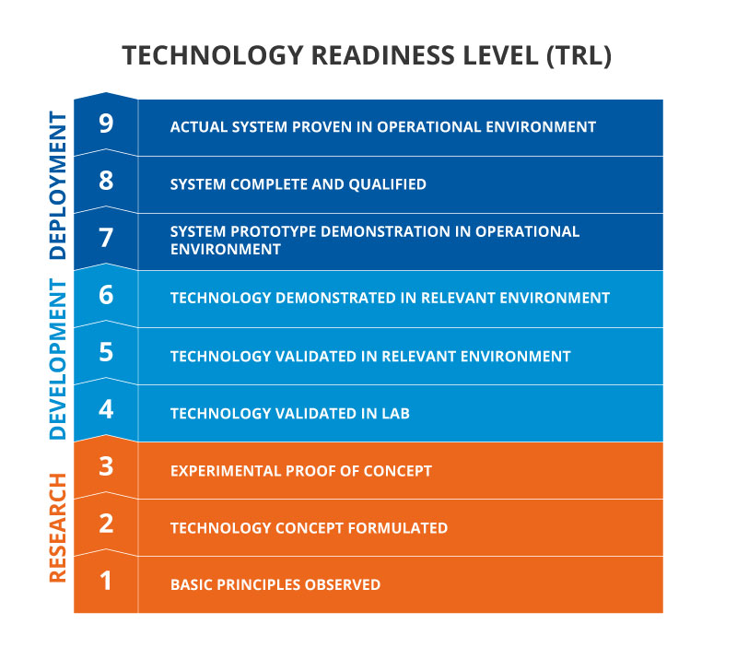
The first phase, called the Alpha phase, regards the fundamental goals and features of the product/service to be developed as well as some concrete evidence on the viability of the project. Likewise, apart from establishing the basic functionality of the product, one has to detail how the client will interact with the product, hence, to imagine, make assumptions, mitigate the risks, and decide on the user experience with the product.
Accordingly, one can prove an idea by the means of two types of prototypes which answer the functionality and user experience problems. We will consider the resulting prototypes as corresponding to the research phase of the Technology Readiness Level scale.
Visual prototype – a simple method to visualize the final product, to perceive its dimensions; generally, this prototype does not have any functionality as it is only meant to illustrate product appearance, sizes, proportions, and even colors (it represents a static model without any working parts). It is mainly used to explore different creative solutions and, in some cases, even to investigate human interaction with the product. This is a cheap and fast method for designers to test and evaluate their solutions without using many resources.
One way of building such a physical prototype is by using some inexpensive materials/tools, like clay, foam, paper, adhesive tape, glue gun, ruler, and pencils for instance. Then one can build low-resolution prototypes by using simple tools to cut, bend and reshape the foamcore (or cut and fold the paper in the desired way, or shape the clay). In this way one can easily experiment and make simple physical sketches of the idea, experimenting along the way different possible variants. In this way a realistic preview of the design can be produced relatively fast, hence such volumetric model can be used efficiently to have an ergonomic evaluation, to test some color schemes and ultimately to convey the product idea to others.
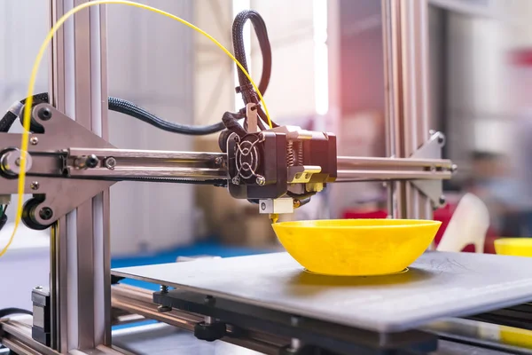
Yet another method of producing a visual prototype is by rendering a digital artefact in a 3D modeling software (like Blender, 3ds Max, Autodesk Maya, and so on). Although this method requires some digital knowledge (hence it might appear harder at the beginning), the outcomes have some advantages as the models produced might be easily modified, reshaped, reused, stored, transmitted, and eventually 3D printed. Commonly used tools to effectively build the prototype out of its digital version are 3D printers and CNC machines. However, the technologies are different: while in the case of 3D printer the product is printed layer by layer, in case of CNC machines the product is carved out of a solid piece of material.
Either way, this type of prototype is commonly built to gauge whether the final product will be appealing to the customer. In this respect, a successful prototype will be able to facilitate communication with people and even give a leverage to convince interlocutors as they are able to perceive a 3D form of an idea (and on which they can reflect). Thus, the designers not only develop and refine creative ideas into the final product, but along the way they are understanding better the customer needs.

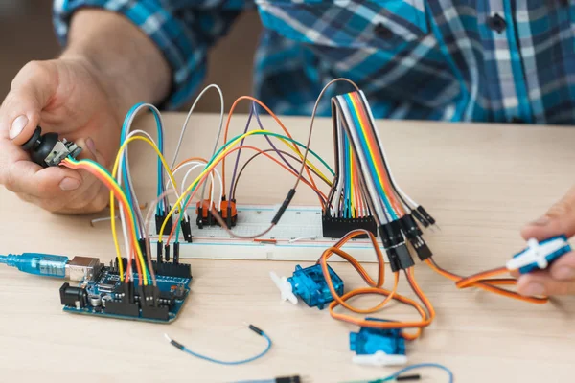
Proof on concept – this represents a basic model that is mainly used to prove the functionality of the idea. As opposed to the previous case, this model is not intended to look like the final product but to prove that the idea can be implemented, hence it evaluates the technical viability. Consequently, the proof of concepts validates a product idea by showing the existence of the required technology for the development of the product. It must be as simple as needed to imitate how the product works; however, since the proof of concept is not the final product, it might also be the case that some (limited) functionality of the product is accomplished by humans or other devices.
By using this model, one can test key hypotheses about the project. The proof of concept is mainly used for internal evaluation and may reveal various design issues at an early stage of the development. However, once the project advances, the prototype can be presented to the stakeholders in order to proceed to the next steps required for launching the product on the market.

More specifically, in order to build a proof of concept one usually checks the following objectives:
- Investigate which are some specific “pain points” of the user and detail them by creating a list of problems which the product should tackle. This is commonly done by directly interacting with potential users/customers in order to get opinions and feedback related to the specific problems faced by them, hence by conducting market research. Additionally, one may use as secondary information the data from government census items, trade association research reports or even other companies’ public information to get supplementary insights on customer needs.
This step is required as a common mistake is to build directly a product by thinking that people wanted and not by performing an evaluation of the product idea.
- Analyze the possible solutions for the identified problems and rate them according to a set of criteria which must include different perspectives: feasibility, costs, time for production, and so on. Once the evaluation is done, the best solutions have to be presented to the potential customers (which provide valuable input). In this way, the solutions are refined and the probability of identifying the most promising one is increased.
- Effectively build the proof of concept according to the data gathered in the previous step while maintaining communication with potential customers (which have to be involved in testing activities and to provide critical and effective feedback). To this aim one has to perform test cases involving different scenarios and to document all the outcomes.
- Improve the product idea based on the comments gathered from potential customers while they are testing the proof of concept. In this way, the product idea is revised to fit the needs of the market. It is worth mentioning that this incremental approach has the role of finding the optimal solution while saving a lot of time.
- Complete the proof of concept by including all the features imagined at the beginning and discovered through customer surveys and direct feedback. At this moment one has an estimation on the resources needed for product development, timeline, and even customer acceptance. Once such details are known one can proceed to the next steps which involve the stakeholders who can agree to support the project. At this stage is very important to give them some tangible proof that the proposed product can be effectively built, and all the presented assumptions are sound. Presenting a clear roadmap is a convincing argument in creating stakeholder confidence in the product idea.

The second phase, called the beta phase, is aimed to include all the knowledge acquired and the changes operated on the product idea as the proof of concept is developed through the mentioned iterated process and the potential client feedback on the visual prototype is gathered.

The beta phase in the product roadmap is a dedicated effort to elevate and polish the product design. It capitalizes on testing feedback and insights gleaned from previous iterations, seamlessly integrating them into the evolving process that inches closer to the ultimate product.

This phase is meant to build a prototype that resembles the final product in both aesthetics and functionality, opening avenues for more thorough and rigorous testing.

This stage is based on two novel versions: the engineering prototype and the production prototype. Achieving this level of intricacy usually demands a team with substantial expertise in both product design and manufacturing.
Once the proof of concept is done (and consequently the technical feasibility of the idea is proved), one can build the minimum viable product (MVP) which represent a „minimal” product that can be released to customers; this product comprises the simplest core features required to validate the concept or idea and gain user feedback. Therefore, while the proof of concept is internally used by the developers, the MVP is used externally by customers and helps the developers to measure the need and desirability of the product.
Minimum

Viable
MVP

Unfinished products that nobody want to use.
The final product that you are not able to build yet.
Product good enough to solve the core problem but has only needed features.

The smaller versions, often termed increments, follow the "minimum viable product" approach, as illustrated in Figure 1. This method provides customers with transparency on the current status, enabling early feedback incorporation in the subsequent development stage. Continuously comparing the actual status with expectations swiftly identifies unnecessary developments, allowing saved time to be directed towards fulfilling customer needs with genuine added value. Consequently, subsequent change requests for implemented features become obsolete, eliminating associated costs.
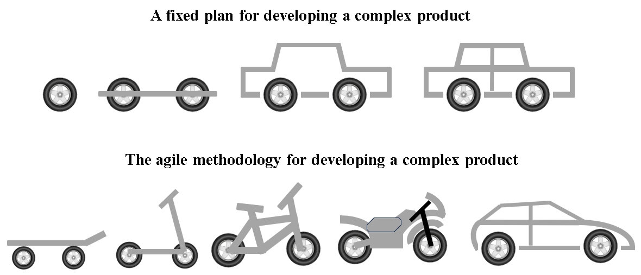
The MVP strategy is based on the value concept – in this regard a wheel has no value to a user but a skateboard does (as the ideea regards the transport of the user)
In practical terms, it's relevant for the team to clearly define the target customer group. This group is often a carefully chosen set of people which most likely will become early adopters, showing greater tolerance for a product's shortcomings compared to those who align with more established technologies. The aim is to gather feedback from this selective group on the Minimum Viable Product (MVP) and use it to (re)shape the strategic direction of further product development.
The MVP serves as a shorthand expression for a dedicated process of creating new products for customer consumption. It presupposes that the product will undergo rapid iteration after entering the market, aiming to achieve a more desirable state. Alternatively, if the market deems the product unusable or undesirable, the product development may be abandoned. In this respect, while developing a MVP it is very common to obey a simple rule (E. Ries): „remove any feature, process, or effort that does not contribute directly to the learning you seek”. Hence, it is important to build a slice across all stages of product development instead of one layer at a time .
Functional

Reliable
Usable
Emotional design
e
Functional

Reliable
Usable
Emotional design
e
Incorporating emotional design into a prototype serves to seize its functionality while scrutinizing or testing customer needs. These prototypes enable us to observe people's reactions to specific concepts, delving into their nuanced responses. Emotional nuances can be encapsulated in a simple prototype because, although emotions are intricate, simplicity can effectively convey them.
The primary goal of an MVP is not on generating revenue, acquiring customers, or building an array of features. Instead, it centers around a singular product designed to maximize learning. This product features a single element that undergoes testing and analysis. Subsequently, the obtained feedback fuels innovation, iteration, and continuous improvement, playing a pivotal role in the agile development process. In essence, MVP is built upon:
- Testing economic viability.
- Spending fewer money on product development.
- Solving one problem of the user by faster product delivery
- Testing the demand of a product by bringing focus on the one value proposition.
- Defining critical drawbacks and reducing remarks.
According to a survey conducted by CB Insights, the reasons for startup failure break down to 12 main reasons, among which we mention running out of cash and failing to raise new capital, no market need, getting outcompeted, flawed business model, regulatory and legal challenges, poor product and so on, It is important to mention here that a large percent of the respondents indicated that there was no market need of the developed product. Hence one needs to truly know what a problem is before solving it.
Therefore, it is imperative that, prior to implementing an idea, we initiate the MVP development process to ensure it aligns with the needs of the target users. This can be achieved by conducting various surveys to gather essential information and pave the way for success.
Expressing the Idea
Addressing key questions is crucial:
What problems can the product resolve?
How valuable can it be for the end consumer?
What motivates consumers to opt for this solution?
It's vital to identify the essential qualities of the product before introducing it to the public. It is a good practice to outline them first, and then construct an MVP based on these foundations.
Considering the Design Process and User Flow
The Design Process is a pivotal step in ensuring the app's convenience and user-friendliness, with a focus on the basics from the user's perspective. Additionally, the user flow is essential to prevent overlooking any elements while keeping the future product and user satisfaction in mind.
Listing the MVP’s Features
During this MVP stage, it's crucial to integrate all necessary features into the product before its development. After listing them, organizing them in order of priority (high, medium, low) is essential. A prototype of the MVP can also be created.
Building the MVP
Once the essential features and market needs are identified, the MVP can be created. It must maintain quality, be user-friendly, engaging, and suitable for consumers.
Building, Measuring, and Learning
Recognizing that end users are the ultimate authorities on the product's drawbacks, collecting feedback initiates the improvement process. The product is tested repeatedly until finalized, with honest user feedback determining its acceptability, competitiveness, and success in the market.

The MVP process offers several key benefits, extending not only to the design team but also encompassing the entire company. The main benefits regard:
• Testing the necessity of the product becomes feasible without committing substantial resources to develop the entire product.
• Accelerating the team's understanding of customer wants and needs through rapid iteration becomes achievable.
• Minimizing wasted development hours by focusing on a minimal set of features for launch is possible.
• Speeding up the time to market allows for the potential to generate sales revenues faster compared to developing the fully featured final product.
• Gaining a competitive edge is plausible, especially when other companies are contemplating entering the same market.
The fundamental principle to reap the benefits of an MVP is to build the simplest testable product, assessing whether the product should have been developed in the first place. The objective of testing is to determine the viability of advancing development or considering abandonment.
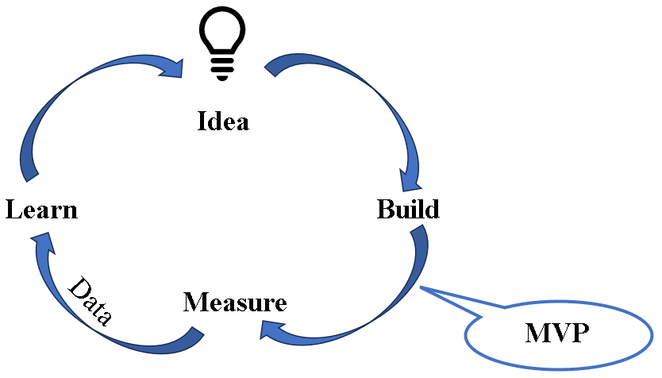
Minimum Viable Product design can still be iterative. MVP offers a clearer and faster journey to a fully featured product. However, minimum viable products do not have to be unexceptional. . The aim is to swiftly bring a straightforward, foundational product to the market, followed by a thorough evaluation of its feasibility and the identification of features for incorporation in the subsequent iteration. This approach centers around user-focused design, consistently gathering valuable feedback to enhance the product with each iteration.
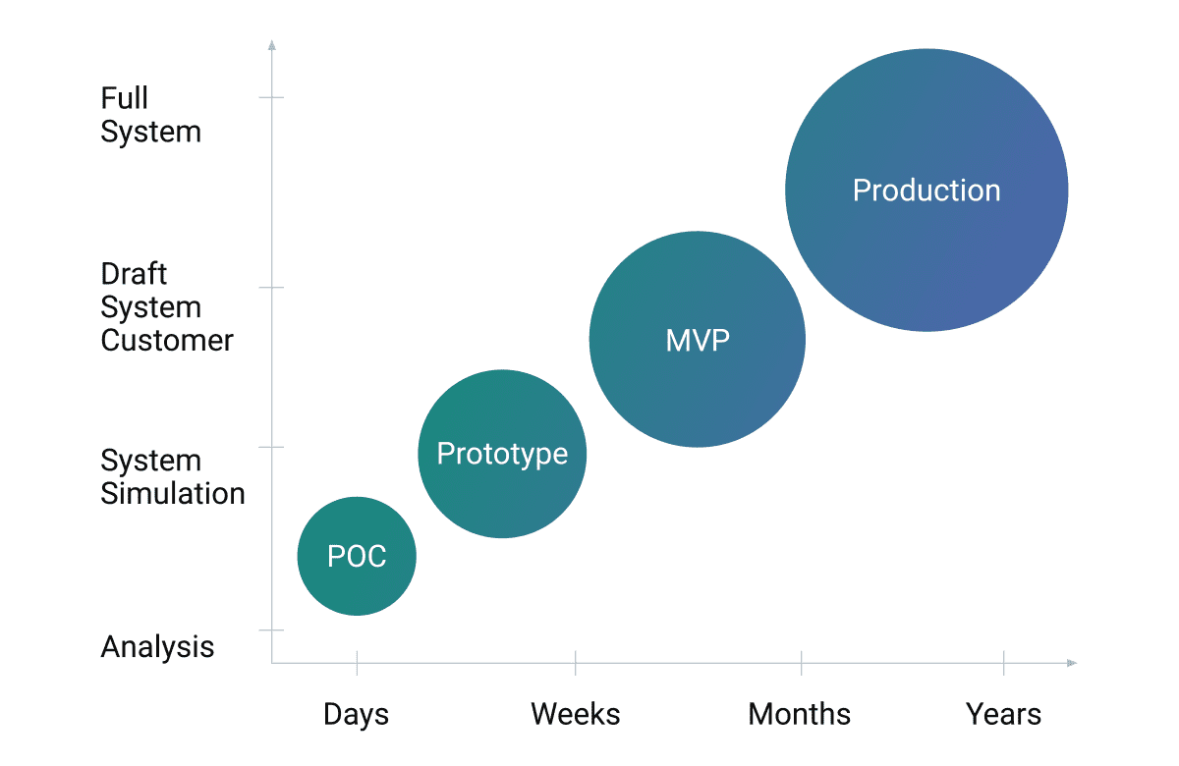
Example:
Care for older people is of major interest for policy in society and this is reflected by important investments not only in the public health system, but also by the private one. Lately, as the institutional facilities involve high costs, for the elderlies who do not need continuous assistance, the focus has been on providing health and social care services at home. However, in remote regions (but not only) the sustainability of such care systems and care provision at home represents a challenging task as it involves many people, time, and costs. Consequently, a sustainable development in the health and social care system (especially regarding elderly people) will have to address economic, social, and environmental perspectives. The problem becomes more acute because it is assumed that elderly people will have an increasing sociodemographic relevance in the future, hence soon will become a problem of economic insufficiency as long-term care for many people is needed. From this point of view, a sustainable technological proposal aimed to prolong health, facilitate independent living, and provide remote medical surveillance is more that required.
In the following example we propose a system which addresses the mentioned social issues. The purpose of the proposed system is to inform in real time the people supporting elderly (doctor, volunteers, responsible or even neighbors) about the condition of the monitored senior citizens by issuing notifications when certain parameters of interest (temperature, blood pressure, heart rate, breathing, and so on) are out of the normal range. Likewise, the system must be able to submit notifications if the subject is falling or some anomaly in the movement is detected (e.g., loss of balance), as well as if the person consciously requests some help.
The system will be implemented on a modular, scalable, extensible architecture that facilitates privacy and personal data compliance. Notifications about the events happening when certain thresholds are exceeded can be issued either on mobile devices (smartphone/wearable), either through a desktop application or dynamic web page. Accessibility to the relevant information is ensured by the data visualizing module and the alerting sub-system. In this way, medical assistance is dispatched when needed. Moreover, through the system, the intervention team is co-located both in the hospital/care facility and at the patient's home, having possibility to consult patient’s records in real-time (its evolution history), hence holding the maximum medical decision-making capacity.
The proposed solution ensures the remote monitoring and assistance of elderly persons in indoor environments, by providing a quality (medical) real time warning and assistance guaranteed by a team of specialist doctors/or qualified personnel. In this way, the dependence of elderly people on long-term medical services is reduced and consequently, their ability to perform different individual activities is kept for longer time.
From this perspective it is the necessary the development of an IT system that is able to facilitate the remote transmission of relevant data among the interested parties (doctors, hospital staff, ambulance staff, elderly people, etc.). To fulfill this requirement the messaging system to be developed is based on the publish/subscribe paradigm. Thus, one has message producers who publish messages in the cloud (sensors, smartwatches, smart bracelets) and message consumers which subscribe to a certain category of messages (which have to be received at the time of their appearance).
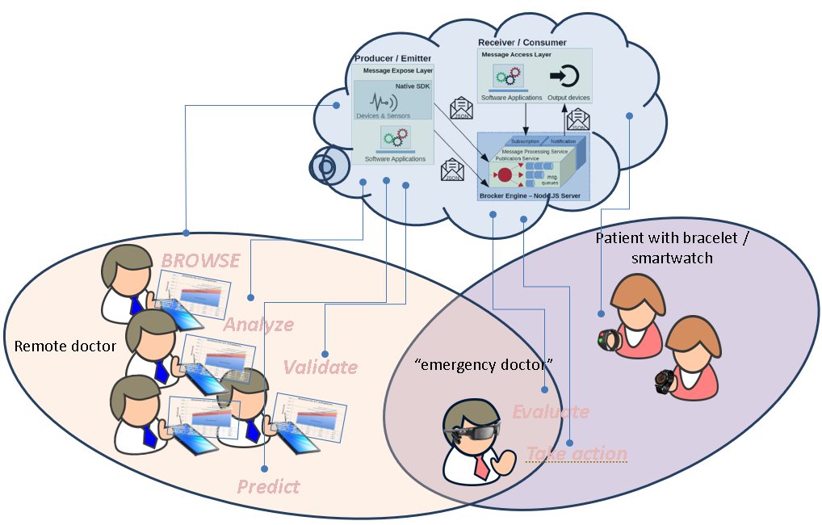
Proof of concept
Equipment and applications:
• an Android smartwatch having several sensors (temperature, pulse, accelerometer). In the current scenario the prototype is represented by an Android Wearable application that uses the pulse sensor temperature sensor, gyroscope, and accelerometer to monitor person’s pulse, temperature, and physical activity (data related to the movement: stepping frequency, step length, and speed; data related to stability: ….). The application is a message producer designed to send structured messages to subscribed consumers.
• a cloud-type application that runs on a server and which manages, classifies, and distributes the received messages to the subscribing parties.
• a web application that displays the content of a message; the application works as a consumer, receiving and displaying received messages
• a smart phone and an application which works as a consumer (receiving, processing, notifying the user, and displaying messages).
Scenario:
The web application (e.g. found in the hospital, social headquarters, etc.) and the application on the smart phone (which can be found, for example, at the family doctor) register as message consumers in the cloud application. The application on the smartwatch (which is found, for example, on the monitored person) is registered as producer of messages in the cloud application. Thus, the messages containing the data collected from the monitored person are sent to the subscribed applications (i.e., the web application and the one on the phone).

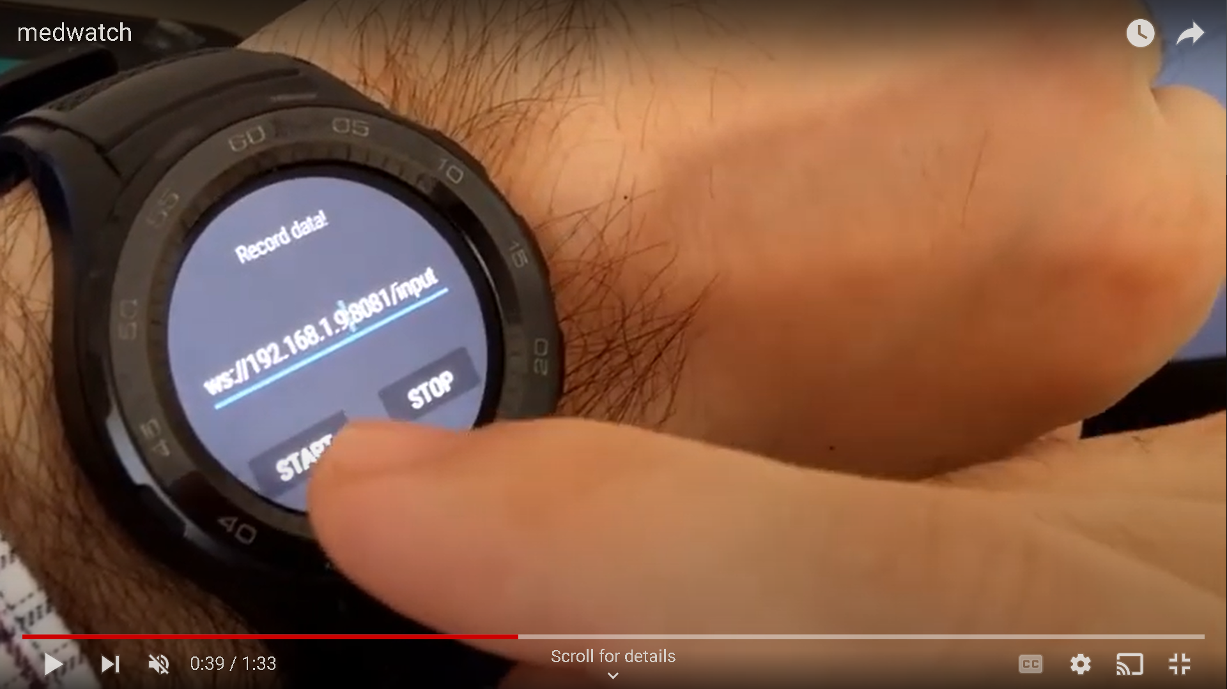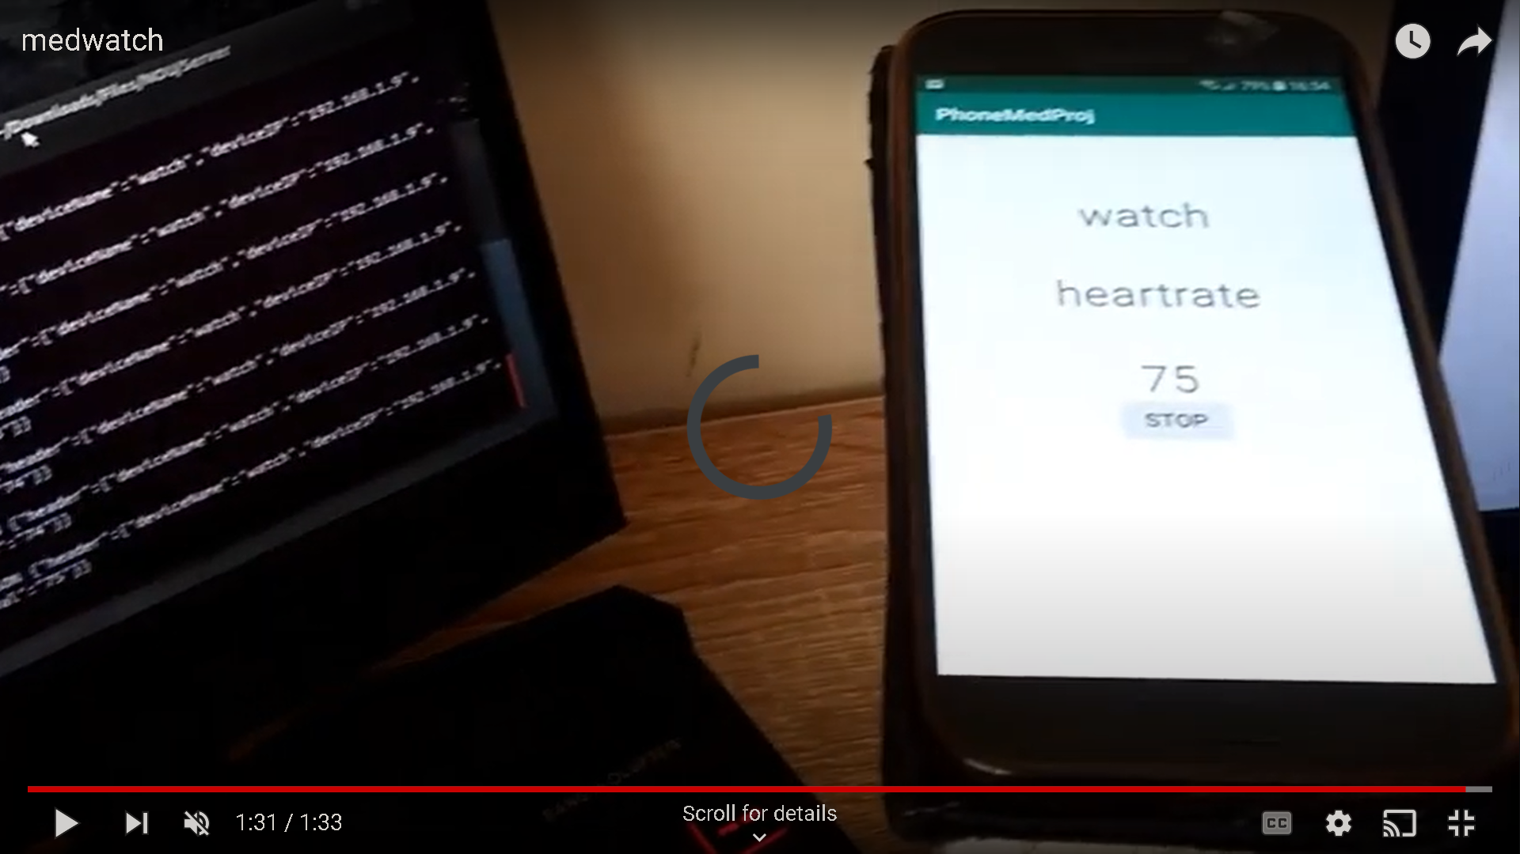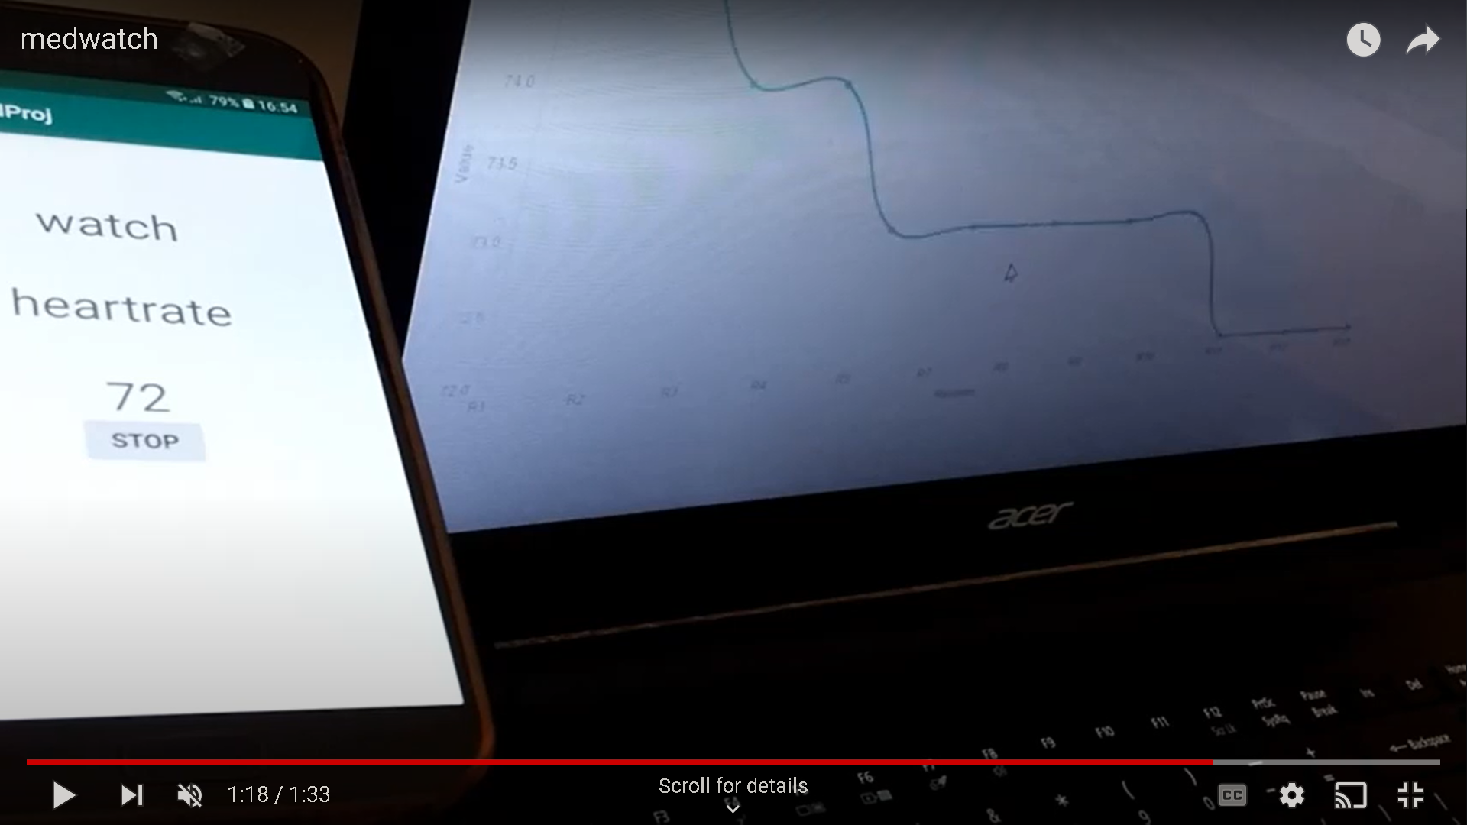

Exercise
Automation and artificial intelligence are poised to alleviate the challenges posed by an aging agricultural workforce and a diminishing pool of field workers seeking less physically demanding roles. The introduction of self-driving agricultural machinery and autonomous drones allows farmers to redirect their attention from monitoring the path directly in front of them to focusing on a more sustainable future for harvests and profits. The integration of data mining and predictive analytics is becoming commonplace, empowering farmers to enhance decision-making, optimize resource utilization, and maximize yields.
The collaboration of robots and machine learning is facilitating the adoption of innovative and sustainable agricultural practices, ushering in a new era where farming extends indoors and reaches unprecedented heights. This shift aims to conserve resources, minimize the use of chemicals, and accelerate time to market.
Design a product that can be used in agriculture and which employs AI to solve in a sustainable manner a need in the field.

References
https://www.cbinsights.com/research/report/startup-failure-reasons-top/
https://ecelliitd.wordpress.com/2020/06/14/minimum-viable-product-mvp/
https://softjourn.com/insights/difference-poc-prototype-mvp
https://www.openpromos.com/magazine29_article11/

