CHAPTER 8
SUSTAINABLE TEAMS

Authors.................................................

- Introduction
When we began writing this chapter, we started documenting using Google, and we came up with the idea of taking this global technology company as an example to illustrate the various concepts we would like to share within these pages. So, we will present a series of notions, necessary to understand what sustainable teams really are, and we will highlight these concepts using Google as an example. So, the first question we thought about was What is Google?

- Organizations
In the context of our chapter, the first answer that comes to mind is simple: Google is an organization. But what are organizations? This term has become an every-day term (Drucker, 1992), organizations being designed with a specific purpose and specialization. While community and society are defined by the relationships of their members, organizations are defined by their tasks. Having this in mind, we see that, in fact, organizations are tools, composed by specialists with their own area of expertise, who apply this expertise in resolving the organizational tasks.
Scientific literature states that organizations are a defining feature of modern societies, that have been studied from many disciplinary perspectives, all these approaches taking into consideration different aspects like (Scott & Davis, 2015):
- individuals, dyads and groups, organizational behaviour, motivations, and decision-making processes (for psychological domain),
- organizational design and bureaucracy (for political sciences domain),
- organizational structures, populations and fields (for sociology domain),
- market influences on organizations, and firm’s interaction in industry (for economy domain).
Organizations are necessary and important because they enable people to accomplish collectively what cannot be accomplished individually (Aldrich, 2008). The author states that organizations are: (1) goal-directed, (2) boundary-maintaining, (3) activity systems. This means that:
- Organizations have purposes and actions are directed to achieve those goals.
- Organizations have a clear distinction between members and non-members, the membership status being contractually defined. Members must follow certain rules, to exercise or delegate specific roles. Thus, organizations involve the establishment of an authority and a reliable scheme of identifying members, which ultimately ensures the organizational autonomy.
- Organizations have a certain technology for accomplishing their tasks. Technology affects social relation in organizations by creating a framework for transactions between roles that are the foundations of an organization.
Some authors, like Edelman and Suchman (1997), speak about two major approaches on organizations: (1) the materialist perspective and (2) the cultural perspective. According to these authors, the first perspective portrays organizations as rational wealth-maximizers, while the second one establishes organizations as cultural rule-followers. We will try to elaborate a bit.
For economists, the word wealth refers to weighting preferences for the things that people want and for which they are willing to pay (Posner, 1985), while if we talk about the wealth of a nation, this is the present value of the flow of benefits, measured from consumption of goods and services, by its people. On the other hand, maximizers are decision-makers who try to find the best possible solution/option (Luan, Liu & Li, 2022), while the ones that are happy with good enough products and services are called satisficers (Weaver, Daniloski, Schwartz & Cottone, 2014). So, organizations try to provide the best choices (or, at least, good ones), by spending efforts to offer more alternatives, thus ensuring the economic process of consumption.
As for the second approach, it is important to emphasize that rules and organizational routines are important facts of organizational life, because they enable the coordination among individuals and organizational units, by aligning activities and goals (Weichbrodt & Grote, 2010), on one hand, but also rules provide guidance and orientation for members, on the other hand. But, besides that, organizations also must follow rules, for example laws and the Constitution of a country, to function properly. So, Weichbrodt and Grote (2010) describe that organizations have someone (person or institution) who creates rules (a rule-maker), someone (usually a group) for whom the rule is meant (rule-follower), and someone to supervise the adherence to the rule (a rule-supervisor).

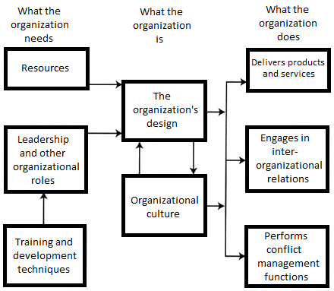
Fig. 1 – Organizational functions, processes, and performance
Figure 1 is a schematic presentation of some useful themes to take into consideration when analyzing an organization (Druckman, Singer & Van Cott, 1997). It is obvious by now that organizational activities have great consequences in people’s lives, like (Tolbert & Hall, 2015):
- Impact on individuals – they can provide growth and development possibilities, challenges, potential for advancement, opportunities for using their competences, engagement and even satisfaction with life.
- Impact on communities – organizations affect collectivities by enriching local life, by encouraging manager’s participation in community affairs, so they may influence the economic aspects, and even the natural environment. The social impact is important, because organization build networks and interorganizational relationships can have positive or negative impact in a community.
- Impact on societies – organizations have important outcomes for the wider society, by shaping social contexts. For example, social stratification, national policies, political decision-making, are some directions in which organizations manifest their impact.
- Impact at international level – multinational organizations exist in every sphere of life, being supported by current technologies and mass-production systems. They operate across national boundaries, having great political influence.
Thus, trying to integrate our case study into this information, what is Google more specifically? According to the Britannica Encyclopedia (2022), Google is an American search engine company, founded in 1998 by Sergey Brin and Larry Page, a subsidiary of the holding company Alphabet Inc., having its headquarters in Mountain View, California.
Browsing the Internet, and accessing Statista Research Department (2022), we found out a few interesting things about this company:
- Starting with February 2022, Google and its parent company Alphabet have more than 70 offices in over 50 countries, and 156.500 full-time employees.
- Being one of the most famous internet companies in the whole world, Google occupies the first place of the most popular websites worldwide, with 45.41 billion visits from November 2021 to March 2022 (Clement, 2022).
- Google occupies this position since June 2010, thus its popularity only increased year after year. Statistics of the most popular websites worldwide, from 1993 to 2020, show that with 81 billion monthly visits, Google has the highest number of monthly visitors around the world.
These numbers raise the question Why is Google so popular? Google is a search engine that uses links to determine the importance of individual pages online (Heitzman, 2017). The two founders wanted to organize the world’s information and make it universally accessible and useful. Certain business models monetized search, meaning some companies sell products, experiences, contents, or services and earn revenues from the sale. Other companies provide access to consumers and charge them for this (Clemons, 2009), Google’s entire business model focused on providing a better user experience. Its algorithm accounted for multiple factors, such as page quality, number of links and relevance to a user’s search in addition to how much advertisers pay, thus improving the original models. That is to say that Google tracks people’s online activities and uses them to provide better search results, connection suggestions and advertisements, in other words, personalized services (Pahwa, 2019). Consequently, Google provided the best product, and everyone wanted to use it (Heitzman, 2017). This fact ensured that there is no other worthy competitor, because no other business has access to such enormous data to provide the personalization that Google became so famous for (Pahwa, 2019).
Furthermore, Google’s focus is around key areas such as search, operating systems and platforms, advertising, and hardware products (Morschett, Schramm-Klein & Zentes, 2015), a few examples being presented in the table below:

Table 1 – Google selected consumer products and services (Source: https://support.google.com/?page=why-ca-mv.html, 2022)
Google Chrome | Google Account | YouTube | Gmail | Google Play
Google Search | Google Maps | Google Cloud | Google Ads | Google Photos
Google Fi | Google Nest | Google Pay | Google Store | Google Drive
Google Accessibility | Google Shopping | Blogger | Finance | Google Earth
Picasa | Google Calendar | Google Docs Editor | Books | Trends
Android | Sites | Google Voice | Google Translate | Google TV
Nexus | Google Families | Hangouts | Google Keep | Phone app
Gboard | Contacts | Google Tasks | Google News | User Security
Messages | Science Journal | Google Kids Space | Google Wallet | Stadia

Its wide selection of products and services places the company among the top four most influential high-tech companies, together with Apple, IBM, and Microsoft (Morschett et al., 2015). By 2006, the term Google was so popular that it was added as a verb to the Oxford Dictionary of English and is defined as “to search for information about (someone or something) on the Internet using the search engine Google” (Soanes & Stevenson, 2006).
So, where do we go from here?

- Organizational structures
When we googled the notion of sustainable teams, and we came across the concept of organizational structure, meaning mechanisms that connect individuals within the framework of their roles, authority, and power (Kanten, Kanten & Gurlek, 2015). They are tools that direct individuals’ behaviours through shared values, norms, and goals (Liao, Chuang & To, 2011). These structures differ according to specific tasks, uncertainties they confront, sources of information they depend on, decisions they must make based on the information they have (Stinchcombe, 1990).
Organization theorists highlight on the existence of two types of structures existing in any organization: the physical and the social structure (De Giosa, 2010). While the physical structure describes the layout, the design (Burns & Stalker, 1971), the relations between physical elements of organizations as buildings and geographical places in which the works are done, social structures describe the relationships between people, positions, and organizational units.

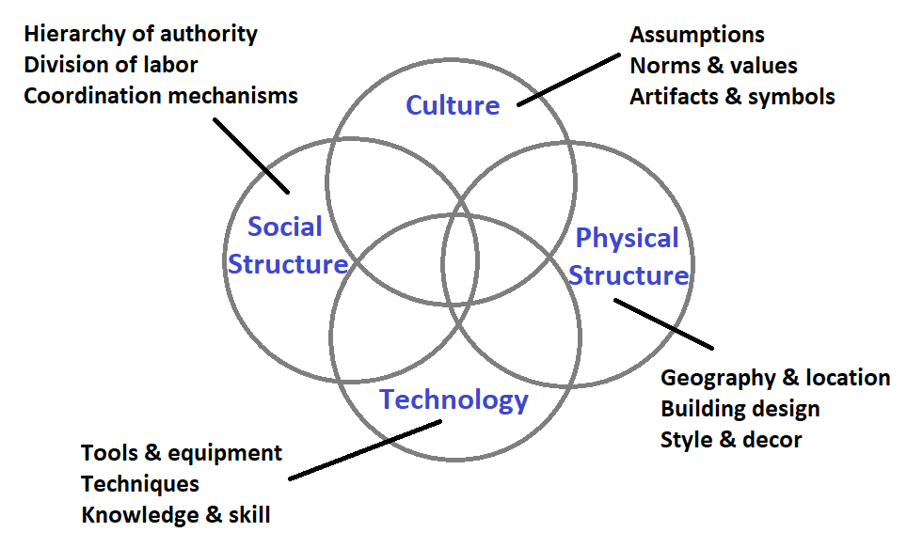
Fig. 2 – Organizational structures

Figure 2 shows a diagram of the main pillars upon which organizational structures are based. Taking Google as an example, we will discuss each of them, starting with the physical structures.

  - Physical structures
Studies have been conducted to outline the relationship between physical environment of work, which has a particular impact on employees’ needs, behaviour, and performance (Ayoko & Ashkanasy, 2019). High level of performances in an organization can be obtained through the fusion of environmental conditions and different types of organizational structural accommodation significant variance in employees
(Child, in Faulkner, 2002). An organization’s physical environment and its design and layout can affect employee behaviour in the workplace. Brill (1990) argues that increasing the organization’s physical layout is designed around the employees’ needs, can maximize productivity and satisfaction by 5 to 10%.
The geographical location of a working place, as well as the surroundings (construction site or office buildings), factors like the quality of air, temperature, lighting, noise level and additional perks of a working place (like parking, coffee shops, childcare facilities, etc.), are important components of the physical structures of an organization.
Child (in Faulkner, 2002) emphasizes three environmental conditions with particular importance:
- Environmental variability – meaning the degree of change which characterizes environmental activities relevant to an organization’s operations. It seems that, because of a higher environmental variability, the experience of uncertainty emerges. Thus, the prevailing structure of organization should be adaptive, with roles open to continual redefinition.
- Environmental complexity – refers to the heterogeneity and range of environmental activities relevant for an organization’s operations. If the degree of complexity is high, decision-makers experience a profusion of relevant environmental information. Thus, a greater role specialization is needed.
- Environmental illiberality – means the degree of threat that decision-makers face in the achievement of their goals from external competition, hostility and even indifference.
Today, the quality of the environment of a workplace is a critical factor for accepting and/or keeping the jobs, namely because it determines the level of employee’s motivation, subsequent performance, and productivity. The relationship between the organization and its employees influences the employee’s error rate, level of innovation and collaboration with other employees, absenteeism, and ultimately, the period spent within the organization (Massoudi & Hamdi, 2017).
A study conducted by Srivastava (2008) shows that the work environment (working condition, welfare provisions, interpersonal relations, trust and support) is a key factor in the variance of employees’ job behaviour and their perception of organizational effectiveness.
Other authors (Ali, Chua & Lim, 2015; Young Lee, 2006) provide evidence that an uncomfortable environment in an office workplace, or a physical environmental status below expectation, may lead to health-related issues, dissatisfaction, as well as an increasing the absenteeism rate. Consequently, high levels of employee absenteeism lead to decreased employee productivity, therefore affecting their work performance.
Another component of the work environment was the support for creative work, studied by Hoff and Öberg (2014), who emphasize that this support can be divided in three fundamental aspects: functional, psychosocial, and inspirational. The authors state that the creative processes would find better breeding ground if functional support (like adequate lighting and tools), and psychosocial support (like spatial possibilities for both privacy and communication), were provided. Their findings suggest that without inspirational support (like brainstorming rooms, dynamic planning, and imaginative interior design), the work outcome becomes less creative. As a conclusion of their study, the authors suggest that the physical environmental support model can be used by companies with an interest to provide creativity supportive workplaces. Some examples about Google company can be consulted on https://www.e-architect.com/articles/google-buildings. Those are proof that Google’s buildings and offices are designed to respond to employee’s needs, encouraging creativity, communication, innovation, collaboration, productivity, and having in mind the use of sustainable elements. A similar example is the Google office in Dublin, with all its facilities provided for all employees (see http://architectures-design.blogspot.com/2013/07/inside-of-google-office-in-dublin.html): office spaces, restaurants, micro kitchens, communication hubs, game rooms, fitness centre, pool, wellness areas, conference, learning & development centre, tech stops, over 400 informal and formal meeting rooms and phone booths, etc.
All these elements are included in what we call the organizational culture, another of the four pillars in an organization.

  - Organizational culture
Organizational culture refers to a set of beliefs and values, part of an organization’s vision or purpose for a long time, to the beliefs of the staff, and the foreseen value of their work which will greatly influence their attitudes and behaviour within the organization (Tsai, 2011). Organizational culture is necessary for the maintenance of a company’s position in market, as well as for the continuous improvement it brings. In big organizations, there are a dominant culture and some subcultures. While the dominant culture refers to the main values which are shared among most of the members (Azizollah, Abolghasem & Mohammad Amin, 2015), the subcultures are usually formed in reaction to the problems, situations, or shared experiences of members. Thus, it becomes obvious that organizational culture has a great impact over employee-related variables, like:

Table 2 – Effects of organizational culture on employee-related variables
Variable | Studies | Effect
Job satisfaction | Salman, Saira, Amjad, Sana & Muhammad (2014) | Organizational environment can positively or negatively influence employee’s attitude towards the work experiences.
Perception | Smith (2016) | Organizational climate shapes behaviours and thoughts, as well as the individual experience of an employee’s work.
Commitment | Dwivedi, Kaushik & Luxmi (2014)  Nikpour (2017)  Huey Yiing & Zaman Bin Ahmad (2009) | Organizational commitment is based on a close relationship between the goals of the organization and those of the individual. Being committed means that the individual is linked or attracted towards the organization on affective, continuance and normative level. It means employees understand norms, values and regulations and behave accordingly.
Performance | Shahzad, Luqman, Khan & Shabbir (2012)  Martinez, Beaulieu, Gibbons, Pronovost & Wang (2015)  Prajogo & McDermott (2011)  Ahmad (2012)  Denison (2000) | Organizational culture influences product quality, process quality, product innovation and process innovation.  A positive and strong organizational culture can make an average individual perform and achieve excellence, because it can positively impact attention to details, outcome orientation, team orientation, aggressiveness, stability, creativity, innovation, and risk taking.  Some organizational culture models, like Denison’s model (2000), emphasize 4 cultural traits: involvement (empowering people), consistency (effectiveness), adaptability (risk taking, overcoming challenges and change, learning from mistakes), and mission (a clear sense and purpose, goals, and objectives).
Leadership | Ogbonna & Harris (2000)  Schein (2010) | Organizational culture can constrain or stabilize individuals, can provide structure and meaning to group members, it provides a framework for human interactions, it allows the management of communication problems, of misunderstandings between group members, it can help with conflict management.

Flamholtz and Randle (2011) list a series of specific reasons why culture is of vital importance for an organization:
- Culture does influence organizational success.
- Culture is a strategic asset, a source of competitive advantage.
- Culture functions as “organizational glue”.
- Culture affects financial performance.
- Culture is a driver or strategic building block of organizational success.
- Culture influences the success of people in organizations.
- Culture is a more important factor than “strategic fit” in mergers and acquisitions.
Three concepts help identify the traits specific to an organizational culture (Prabhu, 2020):
- Social culture, in terms of roles and responsibilities, class distinctions and the distribution of power.
- Material culture that involves everything that people make or achieve, as well as their mutual support when exchanging required goods and services.
- Ideological culture that includes fundamental group values, beliefs, and ideals, as well as emotional and intellectual guidelines that govern people’s lives.
Druckman et al. (1997, p.69) state that most organizational researchers agree on six aspects of the organizational culture:
- Cultures are a property of groups of people and not individuals.
- Cultures engage the emotions as well as the intellect.
- Cultures are based on shared experiences and thus on the histories of groups of people; to develop a culture takes time.
- Cultures are infused with symbols and symbolism.
- Cultures continually change because circumstances force people to change.
- Cultures are inherently fuzzy in that they incorporate contradictions, paradoxes, ambiguities, and confusion.
According to Figure 2, one important aspect of organizational culture are values. Although difficult to define, compare and even harder to build a picture of how values function in organizations (Maierhofer, Kabanoff & Griffin, 2002), scientists tend to agree that values hold a prominent place both in business ethics and in organization theory (Argandoña, 2003). Values were described as needs, personality types, motivations, goals, utilities, attitudes, or interests, thus covering an excessively large conceptual frame. But Maierhofer et al. (2002) state that there are a few characteristics of values, that have been constant, like the desirability, which means that to have a value implies the idea of worth, of significance and importance. Values are part of a person’s belief system, and by extent, of an organization’s culture. The concept can be applied to cultural, societal, organizational, group and individual level (Maierhoffer, Rafferty & Kabanoff, 2003).

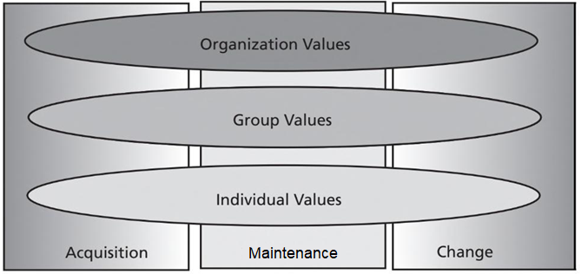
Fig. 3 – Framework for considering when and why values are important in organizations (Maierhoffer et al., 2003, p.7)

Individual values. The first important aspect is the fact that when entering an organization, people already have important work values, that they previously acquired from their families, teachers, other working places, etc., through the socialization process (Bauer & Green, 1998). These values are maintained throughout the organizational evolution because they are the core influences exerted on people’s behaviour, in a consistent fashion. Values influence the selection of means, modes, and ends of action (Kluckhohn, 1951), or, in other words, people tend to behave in a manner that is consistent to the values they hold (Maierhoffer et al., 2003).
But, after a certain amount of time, due to organizational change, employee’s values may change as well, because employees implement and support organizational change (Weldon, 2000). They adapt to their work environment, they detect the environment’s response to their behaviours, they often sense the need for change and ultimately, they select the appropriate actions to engage these changes.
Herbst and Houmanfar (2009) state the importance of the value congruence between individual and organization, because organizational values are shared to some extent across the company by the senior members or by the CEO.
Group values. Within organization, individuals often interact with work groups, teams, or work units (Maierhoffer et al., 2003). When people are working together on the same task, groups are usually formed, and everyone contributes to different parts of a larger task. Thus, values are generated through social interaction among the group members.
Although each member has its own system of values and beliefs, as members of a certain group they assume the group’s identity, and personal values and beliefs are shaped accordingly. Afterwards, group values are incorporated into the self-concept, giving the individual the sense of belonging, which has, as a result, a high degree of cohesiveness. Thus, the authors summarize the fact that during periods of organizational stability, group value congruence produces positive affective and performance outcomes for employees and for the organization.
But when it comes to the necessity of innovation and implementation of change, studies showed that some groups find it easier to adopt change and have the capacity to reinterpret organizational change as beneficial to their own work group (Worley & Mohrman, 2014). Innovative employees are willing to experiment, are results oriented, they have reliable connections with each other (Forrester & Drexler, 1999), sometimes aggressive (Barker, 1999) and they quick take advantage of opportunities (Maierhoffer et al., 2003). Group change is supported by group solidarity, commitment, and good communication.
Organizational values. For these values three aspects are important (Maierhoffer et al., 2003): the content of an organization’s value system, the strengths of that value system, and the extent of individual-organizational fit. Although members may have different values, a central value system is supposed to exist within an organization. Members acquire this system by learning and socialization (for example, a period of apprenticeship). And it is important to do so, because studies show that workers are more satisfied and committed when their values are congruent with the values of their supervisor (Meglino, Ravlin & Adkins, 1989).
Organizational values are malleable during the period of acquisition, but they need to be constantly checked, to ensure that the desired values are acquired. In the period of maintenance, the organizational culture has a substantial impact on individuals’ affective and behavioural reactions, with a great impact, as previously said, on job satisfaction, commitment, or performance. Finally, organizational value systems are likely to influence organization’s change efforts (Burnes & Jackson, 2011).
Gagliardi (1986) states that if the proposed change is antagonistic to the old organizational values, then change is likely not to occur. Of great importance is also the individual-organizational culture congruence, that Gagliardi says it is likely to affect the success of an organizational change. And that is because change also implies rapid searches for alternative ways of acting to preserve the organizational identity, especially when traditional values are challenged.
We feel important to highlight one more aspect regarding organizational values. One of the theorists of human values was Schwartz, who stated in 1996 (p.2) that values “represent three universal requirements of human existence: biological needs, requisites of coordinated social interaction, and demands of group survival and functioning”. Thus, Schwartz defined 10 value types, which we present in the figure below:

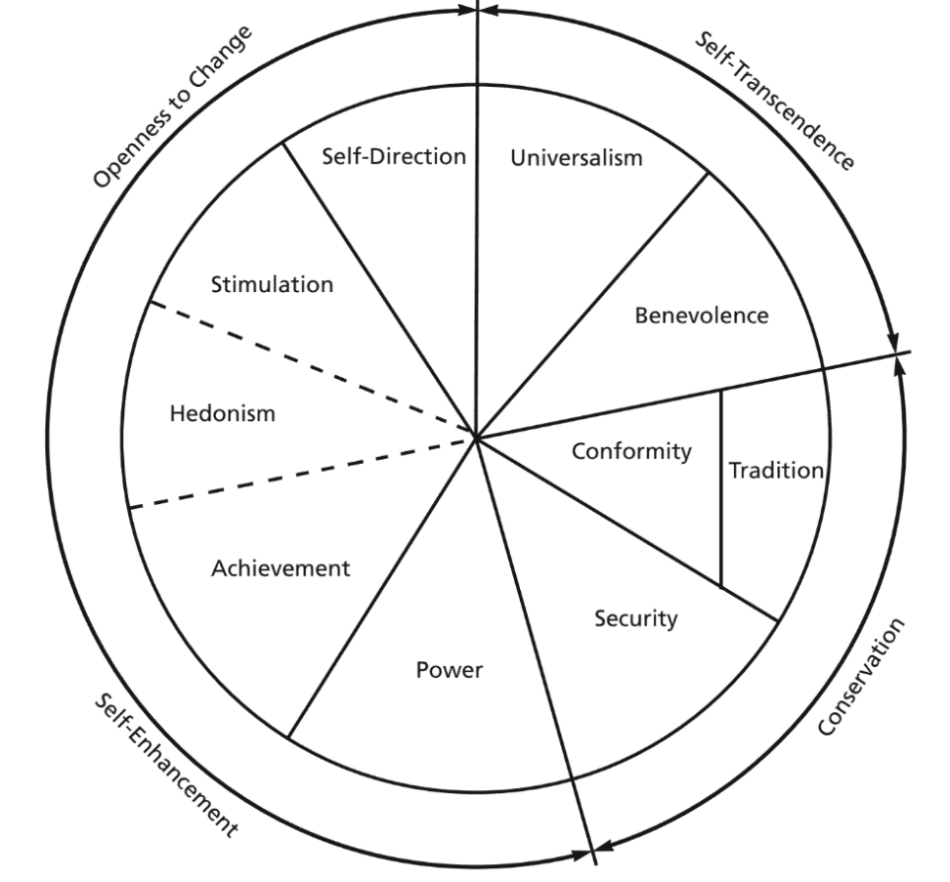
Fig. 4 – The prototypical structure of value systems (Schwartz, 1996)

This circular arrangement suggests that there are dynamic relations between value types, and that compatibilities and conflicts are involved (Maierhoffer et al., 2003). While some value types could come in conflict if they are simultaneously pursued (for example: self-direction and stimulation, versus conformity, tradition, and security), other value types are compatible (for example: power and achievement; tradition and conformity; stimulation and self-direction). Value types are compatible when they are assumed to have similar motivational goals.
Among the common values organizations emphasize, we may also find (Draper, 2019): outcome orientation (achievements and results), people orientation (fairness, tolerance, and respect for the individual), team orientation (collaboration), attention to detail (precision and analytical approach), stability (security), innovation (experimentation and risk-taking), aggressiveness (competitive spirit).
So how are all these organizational culture elements integrated in a company such as Google? If we access https://about.google/, we find out that this company’s mission “is to organize the world’s information and make it universally accessible and useful”. This means the mission of the company is to make life easier with the help of its products, and to improve people’s lives. As organizational values, the company is dedicated in creating client centred products, that can respond to any client needs. But this commitment focuses on both clients and employees, who are offered certain advantages (according to https://about.google/commitments/):
- Expanding opportunities – $2 billion in cash, 1.4 million volunteer hours, $7 billion in ad grants allow the company to provide people with information, tools and services to help them build knowledge, fuel curiosity, and unlock opportunity.
- Protecting users – the company emphasizes that every day it keeps billions of people safer online, with industry-leading security, responsible data practices, and easy-to-use privacy controls.
- Including all voices – Google is dedicated in building a world where progress, equitable outcomes, diversity, and inclusion can be realities both inside and outside the workplace.
- Responding to crises – Google is committed to helping those affected by crises through their products, people, and partners.
- Advancing sustainability – Google unified the practices, partnerships, and products around a single mission — to foster sustainability at scale. By organizing information about the planet, and making it actionable through technology, the tech giant helps people make more positive impact together.
For these commitments to be respected, the company focused on creating a great working culture, that takes into consideration the working environment, the meaning of work, and employees’ freedom (Meek 2015). Anderson and West (1998) state that creativity and innovation have a positive influence over the organizational climate and culture, as well as sharing information in the workplace. Through the organizational culture and climate, companies can guide their purposes and hire employees that fit and support values and purposes in the workforce (Collins & Smith, 2006). Relating to this statement, we can see that Google has established a common, open organizational culture, based on the freedom of sharing ideas and opinions, which in turn creates a comfortable and friendly working environment (Hsieh, 2010).
Flamholtz and Randle (2011) acknowledge that at Google, the key to the continuous development is the talent and creativity of the employees, which in turn is influences by the company’s culture. Its special culture instilled a trio of distinctive core values:
- Don’t be evil. – It refers to integrity and fair treatment of customers.
- Technology matters. – This is a self-explanatory value.
- We make or own rules. – It refers to various unorthodox practices (for example, Google auctioned its IPO shares rather than the traditional approach of allocating them based on an underwriter’s discretion).
Google has, in fact, been able to attract talented people because of its culture. Furthermore, to reinforce their commitment to culture, Page and Brin created the position of chief culture officer at Google, with the mission to retain the company’s culture as it grows and to keep the Googlers happy, thus increasing the likelihood that the company’s culture remains a strategic advantage for Google (Flamholtz & Randle, 2011).
But apart from values, as you could see in Figure 2, in an organizational culture, artifacts and symbols are also included, alongside assumptions, and norms and values. Schein (2010) identifies as artifacts: formality and authority, daily schedule, meetings, decision making process, communication, social events, jargon, uniforms, identity symbols, rites and rituals, disagreements and conflicts, balance between work and family. As an example, Google promotes respect for national cultures and allows employees to wear traditional clothes (Tran, 2017).
The importance of artefacts is crucial for organizational culture, because they are expressed as core business activities, processes and philosophies that characterize an organization. They need to be identified, analysed and compaired. For example, Schein (in Gallos, 2006) emphasizes: if customer focus is the company’s value, then the systems of rewards or accountability should be identified, as artifacts that support customer focus.
The management of the organizational culture means an understanding of the common traits found in all businesses (Prabhu, 2020). This process may have the following steps:
- Identify common artifacts or traits.
- Convene groups of representatives from all levels, functions, and locations to rigorously assess the key artifacts and share the assumptions.
- Summarize findings and share them with all participants to solicit additional insights.
- Create a culture management action plan that supports growth, effectiveness and advancement.
As an important part of organizational culture management, Prabhu (2020) lists the following procedures:
- Hiring practices
- Onboarding programs
- Reward and recognition programs
- Performance management programs
To assess the organizational culture, a survey can be used, with a Likert scale from 1 (a very slight extent) to 5 (a very great extent), which could look like this (Flamholtz & Randle, 2011, p.39):

Table 3 – Sample culture survey excerpt (Flamholtz & Randle, 2011)
Current Statement | Current Culture |  |  |  |  | Desired Culture
 | 1 | 2 | 3 | 4 | 5 | 1 | 2 | 3 | 4 | 5
1. We keep our commitments to our customers/business partners.
2. Our people are the company’s most valuable asset.
3. Our company reacts quickly to changes in the marketplace.
4. Our leaders act and communicate with integrity.
5. People are rewarded on the basis of their performance.
6. Good planning is rewarded.
7. Company policies are applied consistently.
8. Changes that affect employees are communicated quickly and effectively.

The world of entrepreneurship hasn’t only the financial goal in mind, but also the social dimensions within the organization (González-Anta, Orengo, Zornoza, Peñarroja & Gamero, 2021). Oswald, Proto and Sgroi (2009) show that high levels of employee happiness is associated with a 12% rise in productivity. Scientific literature shows that employment quality, health and safety, training and development, diversity and human right, as well as labour laws are the key ingredients in ensuring employee’s happiness.
If we take a quick look at Google, we can see that working at this company, employees enjoy free food served throughout the day, a volleyball court, a swimming pool, a car wash, an oil change, a haircut, free health care, and many other benefits. The biggest benefit for the staff is to be picked up on the day of work. We could ask ourselves what the formula for Google’s success is. The answer is the employees of Google. A great company needs great people. And this brings us to another pillar of an organization, the social structures.

  - Social structures and hierarchy
Child (in Faulkner, 2002) states that organizational structures are formal allocation of work roles and the administrative mechanisms to control and integrate work activities. Cuofano (2022) states that an organizational structure allows companies to shape their business model, based on criteria like products, segments, geography, etc., enabling information to flow through the organizational layers, for better decision-making, cultural development, and goals alignment across employees, managers, and executives.
Basically, understanding the organizational structure, allows the understanding of the entire decision-making process. Cuofano (2022) emphasizes that organizational structures are critical for a series of reasons, like:
- Definition of roles within the organization, so that each employee knows its place and where she belongs.
- Goals alignment that makes groups of people work in coordination to achieve common business objectives.
- Culture development based on the shape of the organization.
- Productivity via a system meant to use the people part of the organization in the best possible way.
- Efficiency in the use and allocation of resources within the organization.
- Better decision-making process by allowing the flow of information within and across several departments.
The author also provides a series of parameters upon which organizational structures can be categorized:
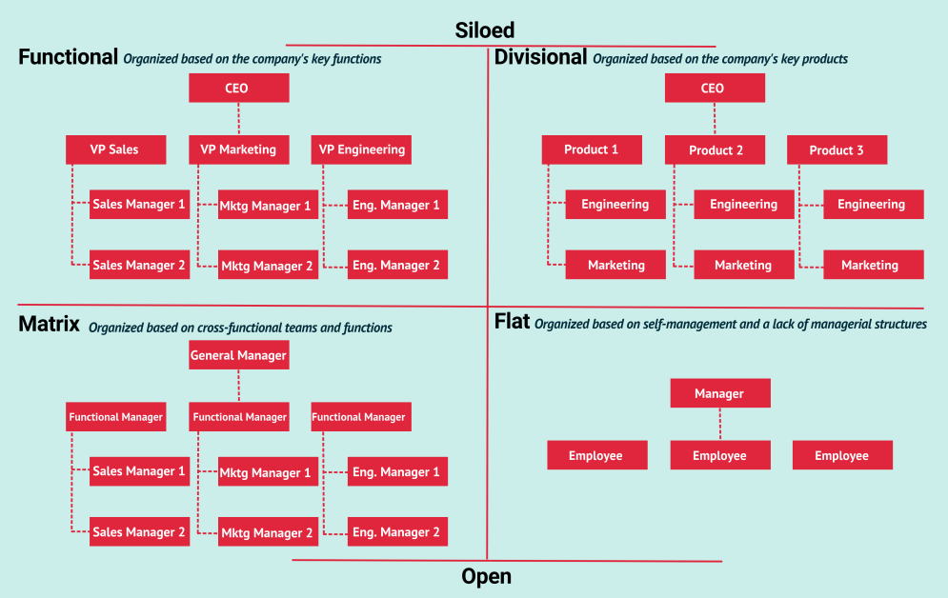
Fig. 5 – Key types of organizational structures (Cuofano, 2022)

We will briefly describe them, according to the cited author:
- Functional organizational structure. People are grouped according to their area of expertise, competence, and specialization. This kind of organization is very bureaucratic and has a top-down approach. Each department has a manager or director, and employees are specialized in specific functions (which may limit their flexibility).
- Divisional organizational structure. Groups are organized according to projects or products of interest for the company. This structure is more flexible to the hierarchical organization, as each division will run almost as an independent business. Each division can be grouped by product line or geography.
- Matrix organizational structure. It blends elements of a functional and divisional structure, but it may be hard to implement. People must report to several managers within the organization, so the communication flow can become challenging and can generate confusion.
- Flatarchy organizational structure. It acknowledges more independence and autonomy for employees, who are closer to the chain of command, and to the decision-making process. Hierarchies are adaptable. Although it’s a model that works for small and medium-size organizations, it’s difficult to implement for large organizations.
As you probably know by now, organizational authority is an important concept in organizational management, providing a useful tool to understand organizational behaviour and how organizations achieve their objectives (Presthus, 1960). The author states that authority is the capacity to evoke compliance in others, through formal systems where interpersonal relationships are structured in terms of the prescribed authority of the actors.
Authority is the main criteria of organizational hierarchy, which consists in the order of organizational members. This order consists of multiple levels and members with more authority occupy higher positions. Draper (2019) provides this general structure of hierarchy:
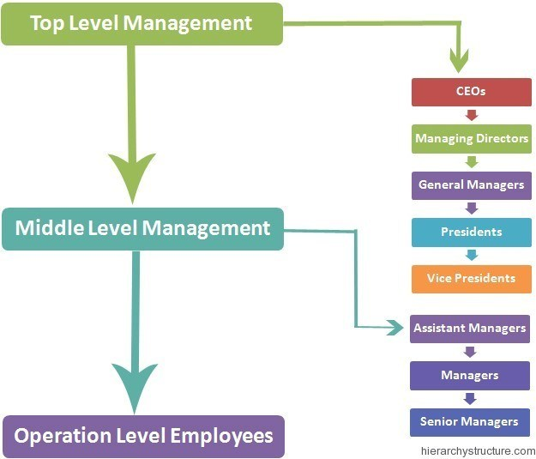
Fig. 6 – Hierarchy degrees (Draper, 2019)
Top level management has a defined structure in an organization and works through official channels. Middle level management has a defined structure, but accepts people work outside their formal business channels. And operation level employees have job descriptions and often challenge authority.
Other important members of organizational hierarchies are:
- Chief executive officer (CEO): is the top executive in an organization who guides and directs the organization to ensure growth, profitability, and development
- Chief operating officer (COO): is typically the second-highest executive who coordinates activities to ensure the organization operates effectively and stays productive
- Chief financial officer (CFO): coordinates all financial activities within an organization and may recommend financial opportunities, such as investments
- Directors: oversee departments and ensure department managers, such as finance, sales, and marketing managers, implement the best policies to ensure productivity
- Department managers: oversee the daily activities of an organization and train employees who work in the department
- Department supervisors: assist department managers in coordinating daily activities by overseeing a group of employees within the department
How do organizational structures and hierarchies look like for Google? Cuofano (2022) states that Google has a team-based organizational structure, a matrix structure with some degree of flatness.
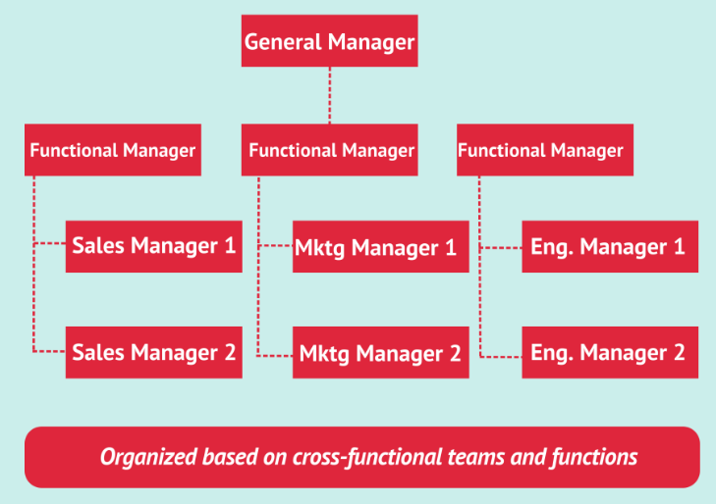
Fig. 7 – Google’s organizational structure (Cuofano, 2022)

Over the years, as the company scaled and it became a tech giant, its organizational structure is morphing more into a centralized organization. According to https://www.hierarchystructure.com/google-company-hierarchy/, Google’s professionals are combined in a systematic manner, into a hierarchy based on power, authority and decision-making efficiency. The following figure allows a better visual support:
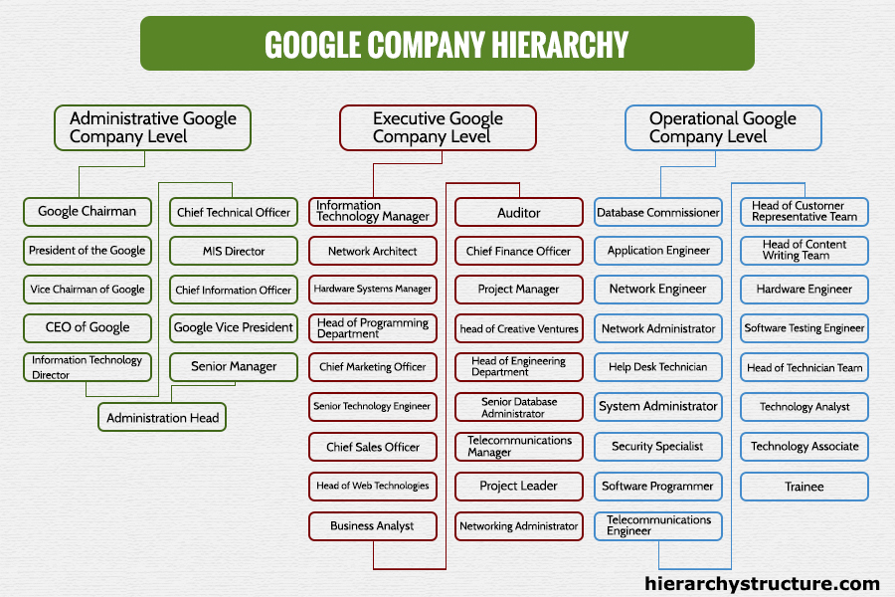
Fig. 8 – Google Company Hierarchy (retrieved from https://www.hierarchystructure.com/google-company-hierarchy/).
The figure shows three levels of categorization: the administrative level, executive level, and operational level. In the administrative level we find professionals taking care of the entire organization. At executive level, professionals are team leaders of their specific departments and handle the entire team of professionals under them. And at operational level we find professionals that manage some definite and pre-specified areas in the company, according to their expertise.
Google’s organizational structure is closely linked to the mission, vision, and values of the company (according to https://howigotjob.com/organizational-structure/google-organizational-structure-all-about-google/). We will explain what this means:
- Functional organizational structure, based on teams that perform specified functions and tasks, while coordinating with other departments.
- Product-based organizational structure includes departments responsible of innovative ideas for the company.
- Flat structure that promotes opportunity for employees to be innovative, creative and to become decision-makers related to their own ideas, thus making them feel important, attached to the company, motivated and effective.
After analysing Google’s organizational structure, we can compare it with traditional organizational structures and see the differences:
- Cross-functional structure. The responsibilities are divided amongst various departments, making work faster and better.
- Horizontal hierarchical structure. In a vertical hierarchical structure, the employee on the lowest position is obligated to report to those who are at the top. At Google, employees can express themselves, and those in lower positions are treated equally when it comes to giving ideas.
- Flatness, flexibility, and autonomy. The company creates flexible working conditions for its employees, allows them to make decisions, gives them flexibility in everything they do, allows them to give ideas.
There are certainly advantages and disadvantages of this organizational structure, and we will present them in a synthetic table.

Table 4 – Pros and cons for Google’s organizational structure
Pros | Cons
Increased productivity and profits | The problem of reporting to multiple heads
Diverse opinions, better ideas | Fewer opportunities for getting a promotion
Effective communication | Stained relations
Widening the horizons of the employees | Frustration when reporting to multiple managers

  - Technology
Child (in Faulkner, 2002) states that organizational structures are associated with contextual factors, like environment, technology, or scale of operation. For manufacturing organizations, technology refers to equipping and sequencing of activities in a workflow, while using physical and informational materials (Woodward, 1965). Other authors, like Aiken and Hage (1968) speak about technology in terms of routineness of work. Basically, technology is seen as a product of decisions on workplans, resources, equipment, knowledge of techniques, etc.
Carson (2019) states that technology helps businesses maintain data flow, manage contacts, track processes, and maintain employee records, thus ensuring effectiveness and efficiency in an organization.

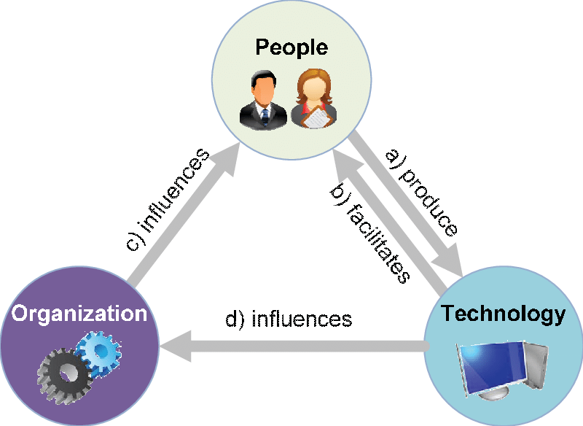
Fig. 9 - People, organizational and technology dimensions, and their main relations (Belfo, 2012)

Neuby (2016) emphasizes that organizational technology is the total of man-made contrivances or developed processes that alter, refine, or create new goods and services delivered by organizations. It includes electronics, software, documents, new techniques, or any combination thereof used in the delivery of services. Belfo (2012) describes a model developed by Orlikowski (1992), which analyses three components: people, organization and technology, among which reciprocal interactions take place. This model acknowledges technology as a creation of human action, as well as an instrument of human action. All three components and their interactions enable knowledge sharing (Van den Brink, 2003, p.29), while technology provides a competitive advantage:
- Technology as a product of human action. People create and develop technology, which is deployed in organizations, maintained, and adapted through human action, thus influencing task execution.
- Technology as a medium of human action. Technology facilitates (by supporting the accomplishment of tasks) and constrains (by prescribing the way a task should be executed) the organizational context and the social practices.
- Institutional conditions of interaction with technology. Values, norms, and practices influence people in their interaction with technology. We should also take into consideration the social and historical circumstances in which the technology functions.
- Institutional consequences of interaction with technology. The way people use technology influences the institutional properties of an organization, by reinforcing or by transforming these properties. Users may conform to the rules and resources that are embedded in the technology, but they also may not conform, thus transforming the institutional context.

Pathak (2020) acknowledges the many developments made in recent years in terms of technology, like Artificial Intelligence, Internet, Big Data, Cloud Computing, Mobile Applications, Augmented Reality and Virtual Reality, 3D printing, Digital Assistants, or Blockchain, everything being available on digital platforms. From E-commerce, E-learning, Remote Working or Online Banking, everything today requires technology. So, the technological dimension includes material artifacts, like software and hardware, utilized by people in organizations in order to perform their job (Van den Brink, 2003).
According to Pathak (2020), the roles of technology are:
- Improved communication.
- Streamlined decision making.
- Propels marketing and business growth.
- Enhances customer relationships.
- Boosts competitive edge.
Thus, technology interacts with organizations (McLoughlin, 2002), gaining more and more value for the organization (McLaughlin, Rosen, Skinner & Webster, 2002), driving organizations towards innovation (Tajudeen, Nadarajah, Jaafar & Sulaiman, 2022), allowing the enhancement of risk management within the organization (Moura, Beer, Patelli, Lewis & Knoll, 2017), sustaining economic growth especially in contemporary organizations (Wiggins, Auton, Bayl-Smith & Carrigan, 2020). But since technology and humans are closely linked, the use of technology depends on decisions made by people, and on negotiations between people in particular social contexts (Scott, in Mullins, 2010).
Van den Brink (2003, p. 85-87) talks about technologies for explicit knowledge, technologies for explicit and tacit knowledge, and technologies for tacit knowledge, offering an illustrative scheme, which we feel it is important in the context of our chapter’s theme:

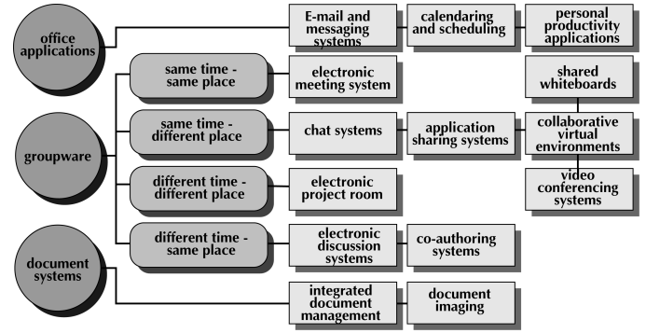
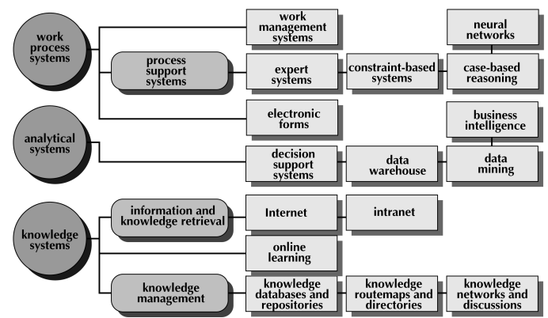
Fig. 10 – Information and communication technology tools (Van den Brink, 2003)

We will discuss these technologies, based on the cited author’s conceptualization.

Table 8 – Technologies for information and communication
Technology | Description and functionality | Tools
Technology for sharing explicit knowledge: knowledge repository | - Ensures information, documents, explicit knowledge components online, indexed, mapped, with easy access and accurate retrieval  - Captures and stores information in electronic/digital libraries  - Contains collections of best practices, business applications, lessons learned, manuals, report, articles, sales presentations, reports, engagement information, customer related data bases, competitor analysis | Integrated document management  Document imaging  Decision support systems  Data warehouse  Data mining  Business intelligence  Internet and Intranet
Technology for sharing explicit and tacit knowledge: knowledge routemap | - Routemaps are guides, directories, or pointers to an organization’s internal and external information sources  - They aid in the codification or discovery of potentially relevant contents  - They provide sources regarding people with special expertise, skills, projects they are currently working on, interests and affiliation  - They may offer links to documents that describe research results, diagnostic tools (for example, bench-marking methodology), or lists of frequently asked questions.  - They may offer online learning opportunities, educational materials (trainings, courses, lectures, video journals, etc.) | Intranet  Online learning  Knowledge routemap and directories
Technology for sharing tacit knowledge: collaborative platform | - It enables communication between people irrespective on time and place constraints  - Seeks to improve coordination, communication, collaboration between people, teams, or groups  - Facilitates teamwork, although it represents a poorer medium in terms of information interpretation, than face-to-face communication  - Encourages debate, dialogue, interaction, creativity, innovation and sharing | E-mail and messaging systems  Calendar and schedule  Electronic meetings, chat systems, applications, shared whiteboards, video conferencing, electronic project rooms, work management systems, electronic forms, etc.

If we talk about our case study, and what technologies does Google use and promote, the following picture describes them pretty extensively (according to https://www.ovrdrv.com/knowledge/google-world-infographic/, which also offers an interactive PDF throughout which all these technologies can be accessed for description).
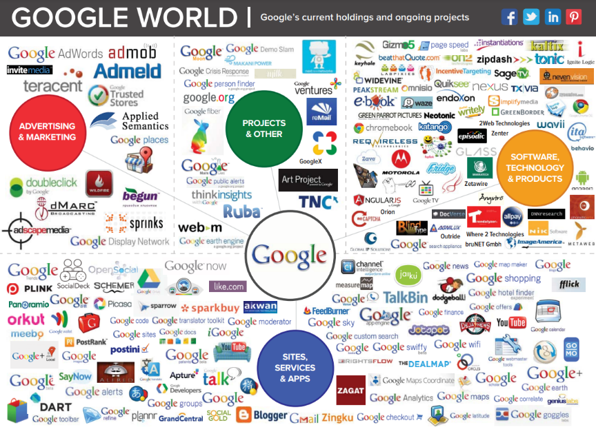
Fig. 11 – Google World Infographic
- Other characteristics of an organization

  - The degree of urgency
Also, as a part of the organizational culture, is the degree of urgency, defined by Draper (2019) in terms of speed with which an organization needs to make decisions and innovate. If the levels of urgency are high, then the organization needs to quickly respond to the changing market, and consequently push projects. If we talk about a moderate level of urgency, then the organization moves projects at a reasonable rhythm, while a low level of urgency allows people to work slowly.

  - Prioritization
The degree of urgency is also important for prioritization. Mathenge (2020) states that prioritization is vital to a business, providing information about the relative importance of a situation, so that the organization will be able to quickly respond or address the situation. Thus, prioritization involves understanding impact and urgency.
Impact can be understood in terms of the effect of an incident, problem, change on business process. Although it is not expressed in absolute terms, impact can be measured in range or degree and can be expressed in words like high, medium, low, or critical, significant, minor, etc.
Urgency is about time and the speed at which the business or the customer would expect or want something, and it depends on business context, needs, and risks. Like impact, urgency can be defined as critical, major, medium, and minor.

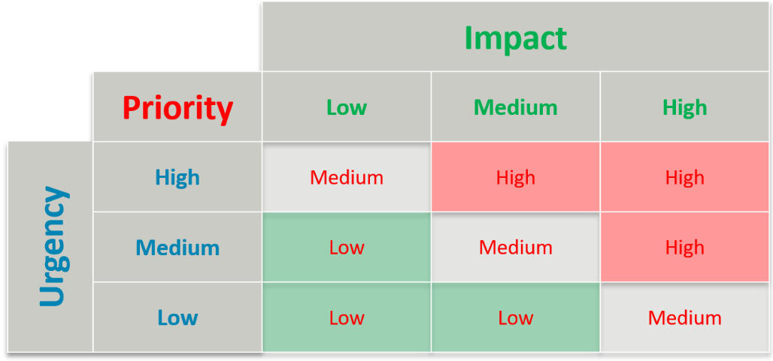
Fig. 12 – Basic Impact, Urgency and Priority matrix (Mathenge, 2020)

Having this in mind, we see that priority is the intersection between impact and urgency and based on the matrix in the figure above we can correlate impact and urgency and find solutions for an easy way to determine service levels and track performance measures when treating incidents, problems, requests, or changes.
  - Management styles
The degree of urgency is in a close relationship with the management style, thus an organization with high urgency tends to be fast-paced and supports a decisive management style, while an organization with low urgency tends to be more methodical and supports a more reasonable management style.
Lex Sisney (2011) speaks about four management styles, visible in the way people operate in the world. These management styles are driven by 4 forces: Producing, Stabilizing, Innovating and Unifying. They are all present in each human in some form, but one or two of them are relatively stronger. This chart that Sisney proposes shows how each work style compares to the others:
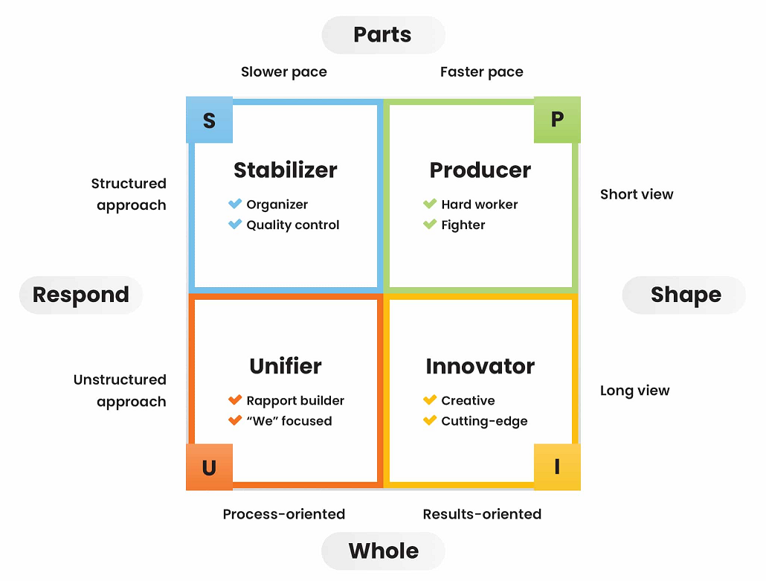
Fig. 13 – The four management styles (Sisney, 2011)

As far as the description of these styles is concerned, Sisney (2011) conceptualizes them like this:
- The Producer. Has a high drive to shape the environment and focuses on the parts that make up the system. This type has a fast pace, takes short-term view, is result-oriented, and follows a structured approach. It is focused on what to do now and prefers working hard to get things done. This style characterizes people that are focused, determined, and energetic.
- The Stabilizer. Has a high drive to respond to the environment and focuses on the parts that make up the system. It has a slower pace, takes short-term view, is process-oriented, and follows a structured approach. It focuses on how to do things and prefers working methodically to get them done the right way. This style characterizes organized people, that pay attention to details, and take time in their words and actions.
- The Innovator. Has a high drive to shape the environment and focuses on the whole system. This type has a fast pace, takes long view, and operates in an unstructured way. It is focused on driving change, while finding new and better ways of doing it. It has a why not? kind of approach. This style characterizes people that are dynamic, creative, and intuitive.
- The Unifier. Has a drive to respond to the environment and focuses on the whole system. It moves at a more measured pace and it’s process-oriented like the Stabilizer, but takes an unstructured, freewheeling approach and a long view like the Innovator. It is focused on who is involved and on the interpersonal dynamics of the group. This style characterizes people who are likeable, gregarious, and warm.
One more important thing that Sisney (2011) emphasizes are the basic characteristics of each work style and how it tends to view as friends (those they admire, respect, value, etc.) versus foes (those they devalue, discount, disrespect, etc.), as well as what tends to cost in energy (emotional drains like anxiety, stress, frustration, etc.) versus give it more energy (emotional gains like satisfaction, happiness, confidence, etc.). We will reproduce this figure as well:

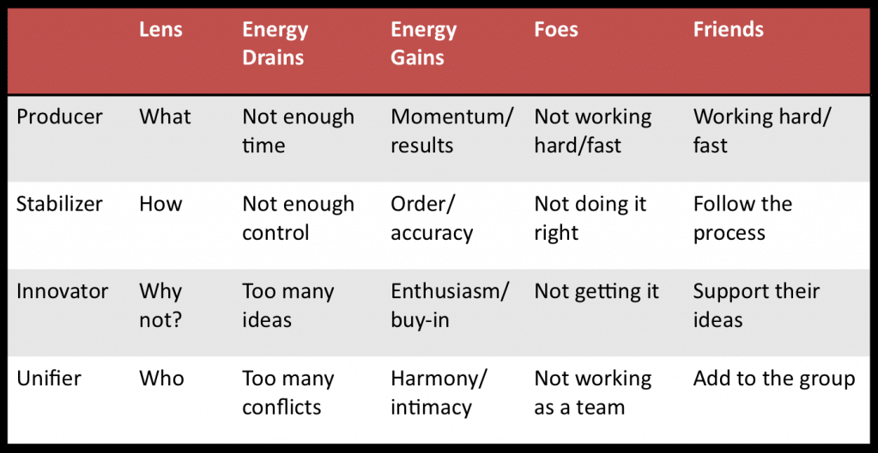
Fig. 14 – Friends vs. Foes | Gains vs. Drains in Management Styles (Sisney, 2011)

However, this is not the only classification of management styles. Pinegar (2019) offers another interesting classification, starting with the idea that a management style is a particular mindset and set of strategies a manager uses to carry out an endeavour, from idea to closure. Thus, the author presents the following types with specific traits for each one:
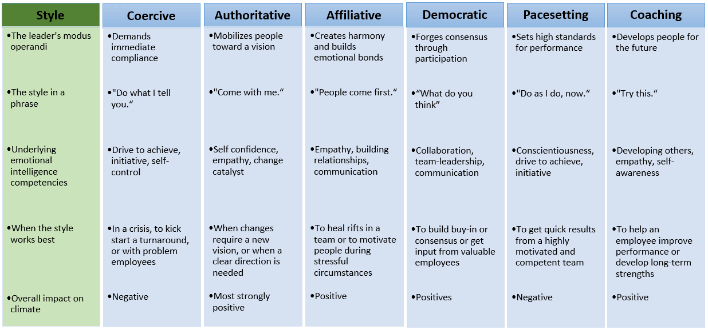
Fig. 15 – Management styles (Pinegar, 2019)

Although the scientific literature has multiple ways of discussing the management styles, we offer one more approach, based on the information available on https://nextstepsresearch.com/management-assessment/management-style/, and the description of each specific style:
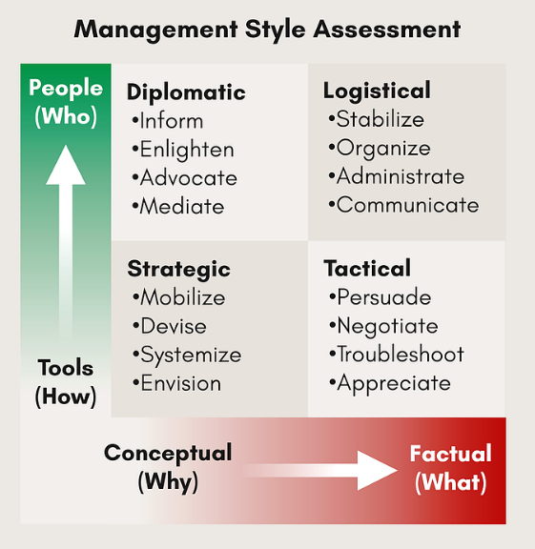
Fig. 16 – Management styles (Next Steps Research, available at https://nextstepsresearch.com/management-assessment/management-style/)
  - People orientation, task orientation, functional orientation
CLAUDIA + RALU

- Hiring practices
According to Sukalova, Stofkova, & Stofkova (2022) the effective functioning of the company is greatly influenced by the company's employees. Other authors consider human resources to be the most important assets and resource in terms of business performance (Batarliene et al. 2017). The authors of Hewett & Shantz (2021) define the issue of human resource management as a philosophy that creates incalculable value for the company. In this context, human resources practices are considered valuable because they strengthen the performance of companies.
Often the term "personnel policy" is associated with personnel strategy, which defines strategic and corporate goals, which the company wants to pursue in the future (Sukalova, Stofkova, & Stofkova, 2022). An analysis by Alerasoul et al. (2022) highlights key areas for the organization's development: human capital, measurement and auditing, internal and external communication, infrastructure and technology. Companies that achieve efficient use of human resources can benefit in their company from cost reductions and increased profitability, which is why in the selection of potential employees, in light of organizational goals and objectives, companies are increasingly focusing on experience and skills (Sukalova, Stofkova, & Stofkova, 2022).
According to Sukalova, Stofkova, & Stofkova (2022), thanks to the knowledge, experience and skills of employees, the market value of the company increases. As Van Lancker et al. (2022) identified, the most commonly practiced resource management activities include: creating labor systems, recruiting employees, educating employees, replacing and compensating, and implementing new activities.
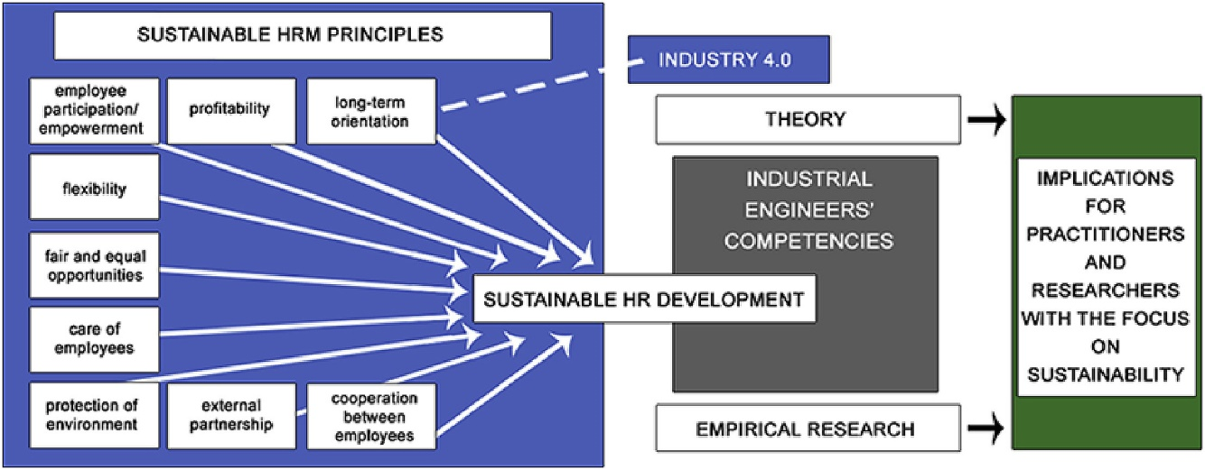
Fig. 17 – Principles in sustainable development of human resources (Source: Piwowar-Sulej, 2020).

In an increasingly environmentally conscious world, businesses are gradually being forced to mitigate the harmful effects of their operations on the environment. Integrating sustainable practices with human resource management leads to environmentally conscious employees. Sustainable HR management practices can be used in the recruitment process to attract quality potential employees. A company that applies sustainable human resources management appears in the eyes of stakeholders as a reputable and responsible employer and has a greater attractiveness for candidates. They, in turn, have greater intentions to look for a job. This is reinforced when the candidate himself or herself has high environmental values and attitudes, leading to better fit between person and organization, increased performance, and competitive advantage (2021), "Going green: increasing organizational attractiveness via sustainable practices and environmentally-conscious recruitment," Human Resource Management International Digest, Vol. 29 No. 5, pp. 45-47. https://doi.org/10.1108/HRMID-06-2021-0131.
According to Piwowar-Sulej (2020), sustainable human resource management refers to the concept that combines the idea of sustainability with the soft approach to human resources. This approach promotes the foundation of an HRM strategy on promoting a culture of trust and cooperation and developing employee engagement, one component of which is loyalty to the employer.
Piwowar-Sulej (2020) supported the idea that HRM's soft approach aims to achieve adequate financial results, but through the policy of building a good "employer-employee relationship".
A series of researches conducted in this direction showed that a soft strategy is effective in retaining an employee for a longer period of time in an organization and encouraging him to share knowledge, work more productively, act with passion and commitment, generate creative ideas to achieve business goals (Smaliukienė et al., 2017; Ogbeibu et al., 2018; Kim and Shin, 2019; Meier et al., 2019).
Pellegrini, Rizzi & Frey (2018), supported the idea that sustainable employee behavior refers to a wide range of behaviors, such as involvement in corporate social responsibility (CSR) projects, positive attitudes towards diversity in the workplace, proactive engagement in environmentally responsible actions, development of green initiatives, and promotion of environmentally friendly products to customers (Gond et al., 2010).
Such behavior can be encouraged through appropriate management practices such as "sustainable human resource management," defined as human resource (HR) activities that improve positive environmental and social outcomes (Jackson & Seo, 2010; Kramar, 2014; Renwick, Redman &, Maguire, 2008, 2013).
But let's identify as such what best practices in recruiting staff could consist of in case studies conducted on a range of sustainable companies.
So let's take Google, for example.
Google's success relies on its high-quality human resources. In general, the company focuses on intelligence and excellence among its employees. Google's HR management also includes carefully selected strategies, methods, and techniques for recruiting and selecting and retaining high-quality workers. The firm's recruitment practices and selection process ensure an adequate workforce. Google's retention programs are designed to retain excellent employees. These programs also attract employees to the firm. The company is now one of the best places to work. This popularity and positive perception indicate the success of the firm's human resource management in recruitment, selection and retention of employees (Lombardo, 2017).
One of the most notable statements by Eric Schmidt, CEO of Google Inc. is that "Google invests in people." The main reason why people from different cultures have dreamed of being recruited and hired by Google is that the company offers perhaps the most outstanding job compensation packages that any normal employee could ever benefit from.
To attract the best employees, Google lures them with the promise of wealth and luxury, offering employees almost everything an employee could need, from absurdly high compensation to extravagant and luxurious benefits such as gourmet food, car wash, gym, snacks, exercise classes, dry cleaning services, Car services, haircuts, oil changes, massages, checkups and much more, all for free.
However, the recruitment process was also far beyond the ordinary. Several people who had experience in Google's recruitment process say that the experience was totally disturbing. An applicant who received interviews for Google had five to seven interviews in one day for two to three consecutive days. The applicant claims that the interviews were very tough with some of the brightest people in the world, conducting the interviews full of teaser, algorithmic problems and IQ tests.
Another applicant who had experience with Google's recruitment process claims that his experience with Google was one of the most disturbing adventures of his life. The interviewers were looking for extremely brilliant people and so the recruitment method was full of IQ tests, teasers, algorithms, data structures and a lot of math involved in it.
Google selection process
Google is arguably the best recruitment leader in the world. Google is known for the various unique approaches it has used to attract the cream of the crop or the best of the best. One way is through hiring branding. Google has so successfully used its brand to attract the most talented and highly competent people in the world. Because of their claim to provide the best employee-employer experience backed by the many perks, benefits, and high salaries Google employees enjoy, Google has become the world's most desirable companies for men and women.
Echoing the example of Google, the recruitment process is described below:
Sources. Google's HR management uses a mix of internal and external recruitment sources to maintain the adequacy of its human resources. The company uses promotions, transfers and interns/trainees as the main internal sources of recruitment for HR needs. On the other hand, Google's external recruitment sources include educational institutions and job ad respondents. Most of these ads are available through the Careers section of Google's website. Through these sources of recruitment, the company facilitates a continuous influx of skilled workers while matching the capabilities of these employees with HR needs.
Methods. Given the combination of internal and external recruitment sources, Google uses indirect methods and direct recruitment methods. Indirect methods are more significant for the company. These indirect methods include advertisements on the company's website. However, human resource management at Google also uses direct methods in the form of contacts with potential interns and future employees through academic institutions. This combination of direct and indirect recruitment methods is aligned with the mix of internal and external recruitment sources to meet Google's HR requirements (Lombardo, 2017).
Google's recruitment process for engineers
With a mission to organize the world's information and make it universally available, Google is looking for candidates who are absolutely sure of their interests and passion, aside from their skills. The hiring process at Google is as follows:
Step 1: CV screening
In this initial screening step, the hiring manager goes through all application forms and resumes received to find potential candidates. It then contacts the selected candidates to inform them of the next steps. Here, you may be asked to take a short assessment online, such as a coding test if necessary.
Step 2: Interview
The interview process is more or less the same for each job profile.
It includes the following steps:
1. Virtual interviews: These are designed to assess the candidate's experience and key skills required for this role. These can be short video calls or phone conversations lasting 15-20 minutes.
2. Work on the project: candidates may be asked to do some coding work before moving on to the next stage. The project could be related to any case study, writing sample code, or any other task that helps the recruiter understand your approach to solving a problem.
3. In-depth interviews: This is a rigorous stage that can include more than 3 structured interviews in a day, each of 30-45 minutes. It could be an on-site interview or via video. The questions asked at the in-depth interview stage assess your skills and knowledge to find out if you fit the role of the job. Questions can be open-ended/behavioural interview questions or simple technical questions. Google follows headings to evaluate candidates to maintain transparency throughout the interview process.
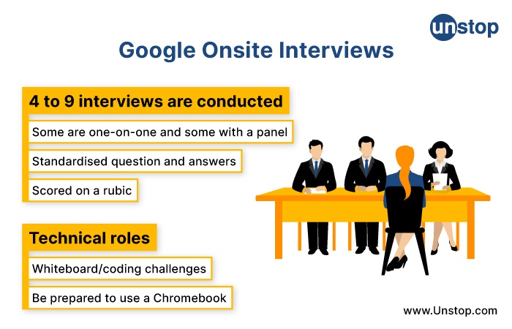
Fig. 18 – Google interviews (Source: https://unstop.com/blog/google-recruitment-process)
To answer technical questions in computer science, you need to be thorough with topics such as data structures and algorithms, hash tables, stacks, matrices, algorithm space, time complexity, system design, and object-oriented programming. Knowledge of at least one programming language such as C++, Python or Java is important.
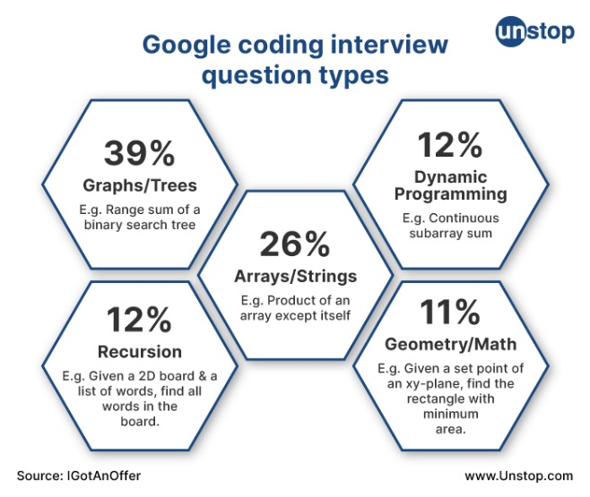
Fig. 19 – Question types used at Google (Source: https://unstop.com/blog/google-recruitment-process)

Step 3: Final evaluation and review process
The candidate is evaluated on the basis of everything - application form, CV, projects, tasks and answers of candidates to interviews. Then, ranking is done based on the candidate's performance to determine the results of employment. After a proper evaluation, the hiring team selects on the list of the most suitable candidates for the position.
Once the list of the most suitable candidates is ready, the compensation committee reviews and finalizes the compensation/salary for the offer, and the executive director reviews the job offers before they are extended to the candidate.
Step 4: Hiring decision and offer
The recruiter reaches the selected candidates with the offer. Once the offer is accepted, the Google application process begins where the team in question prepares the candidate in terms of insurance, company culture, benefits, badges, etc.
How to prepare for Google interview?
The Google interview is a hard nut to crack. But a well-structured strategy can help you navigate the process well and confidently face even the toughest interview questions. One way to perform well at the interview is to PRACTICE. Apart from honing your technical knowledge of important topics, practicing coding is a must, as a major part of the interview will require you to use your coding skills. In addition to coding on your computer, try coding on a whiteboard. This practice will definitely help you during the interview. Participating in mock interviews or online interview coaching can also help you improve your training.
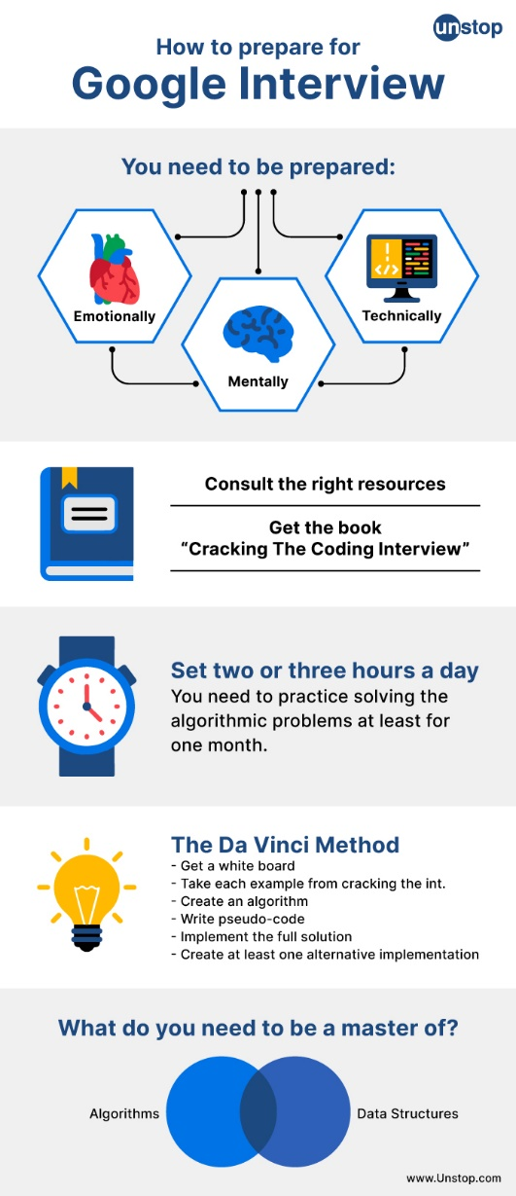
Fig. 20 – Requirements for a Google interview (Source: https://unstop.com/blog/google-recruitment-process)

Overview of Google's hiring process
The hiring process at Google involves several rounds of analysis and interviews over an 8-week period. Your resume is checked by a recruiter to make sure it aligns with the role you're applying for. If they think you'd be a good fit, you'll undergo a phone review where the recruiter asks you some basic questions. The interview process will officially be ongoing after this round.
Google conducts a series of on-site interviews to assess whether a candidate is qualified for the chosen position. Depending on your role, you will engage in 4 to 9 interviews examining your previous experience and technical knowledge. You'll be expected to answer technical questions, and you may even be asked to complete a short project.
Once the interview process is over, Google's hiring committee (who has never met you) will review all the information you've provided so far. The decision to hire or not will eventually be made by them, after which you will receive the news about your application.

Timeline of the Google interview process
How long does the process take?
While Google's interview process was much longer (taking up to 24 weeks), it was significantly shortened. Now, the entire process takes place in just eight weeks, with 4 to 9 interviews including a phone review and on-site interviews.
Step #1: Resumption of screening
Resume verification is where Google's hiring team reviews your resume to see how it fits the role you applied for. If your experience, skills and qualifications seem to be suitable for the job, recruiters will move you to the next part of the hiring process.
It's worth noting that Google wants to see real data on your resume. Talk about your past accomplishments in measurable and quantifiable terms that showcase your work and put you ahead of other candidates.
Step #2: Phone interview
In the Phone Interview, the recruiter asks the candidate some high-level questions from a template to see if they are still suitable for the job. You will receive a call from a recruiter (lasting about 30 to 60 minutes) in which they will tell you more information about the role and ask you some basic questions to see if you are a qualified candidate.
The recruiter will then set up an interview between you and the hiring manager if they are happy with your answers.
Step 3: On-site interview
The hiring manager will conduct a series of on-site interviews to find out more about who you are and your qualifications. This generally takes between 4 and 9 interviews, depending on your role. And it sees you answering technical questions related to the work you would have done if you had hired.
Step #4: Hiring Committee Review
Everything you've shown in the hiring process so far will be reviewed by an hiring committee. A package with all your information, including your resume and feedback from your interviews, is compiled for committee approval.
Google uses a group of people with dissenting opinions you haven't met before to decide whether or not an applicant gets the job, and it's not always easy to say what they're looking for. Their decision often comes down to your skills, personality, and experience.
Step #5: Decision Making
If you got here, you just need to negotiate the terms of your offer. work with the recruiter. You can set up a phone call with them to discuss your benefits. and come to an understanding.
How to complete the interview process to what they want
Use the STAR method, taking a few keywords from your job description and including them in your experience. detailing the situation, task, action and outcome from previous experiences will help you best align your resume with the role and present your achievements in a measurable way.
Build your network to get your foot in the door
It has been shown that networking with other professionals greatly increases your chances of success and helps you see your resume by the right people. However, don't just ask for a job. Make real connections with people and they will be more willing to help you in the future.
Practice answering behavioral and technical questions
Answer questions using the STAR method to provide a story that demonstrates your worth. By organizing your responses with STAR, you'll keep the hiring manager engaged and wanting to learn more about who you are and what you can bring to the table.
Google interview questions:
- Why do you want to work for Google? Potential response: I like Google's commitment to user experience. I've optimized the user experience for several apps I've worked on, and I'm fascinated by Google's quality assurance process here.
- What is your product? Favorite Google and how would you improve it? - In interviews with the product manager, it is best to divide your answer into three steps: the company's business goal, the problems the user wants to solve, and the solutions that the product will provide.
- What type of work environment do you prefer? - Hiring managers want candidates who fit the team, so it's vital that the company culture is right for you. Asking about team building events, such as workshops or happy hours, is an example of how you can communicate your enthusiasm to work with others. Tell your hiring manager about great past experiences you've had in friendly work environments.
- How do you think digital marketing will change in the next five years? - Digital marketing is always changing, and hiring managers want someone who thinks ahead and can predict future trends. For example, you can link the current state of digital marketing to the growing presence of online society, due to the advancement of technology and the COVID-19 pandemic. People communicate with each other and make decisions online, so it's important for companies like Google to stay at the forefront of social media platforms and new technologies.
Conclusion
Anyone can become the right candidate for Google with the right effort. By aligning your resume with your job description, using storytelling in interview responses, and having deep self-knowledge, you can complete the Google interview process. Those who want to work fewer days a week will also want to explore tech companies that have a 4-day week.
https://mentorcruise.com/blog/the-google-interview-process-25c6e/

But let's identify how we could integrate these best practices in tourism and spa companies?

- Team Effectiveness adica vorbim despre PERFORMANCE, ATTITUDINAL OUTCOMES, BEHAVIORAL OUTCOMES ROLES, RESPONSIBILITIES. – DORINA + MARIANA

Homework for students

